5.1 Day 1: Graphing Sine and Cosine Functions

To graph the sine and cosine functions that involve transformations. To be able to determine the domain, range, max/min, amplitude, period and intercepts of sine and cosine.

<https://goo.gl/YYLA92> <https://goo.gl/sRmEh>

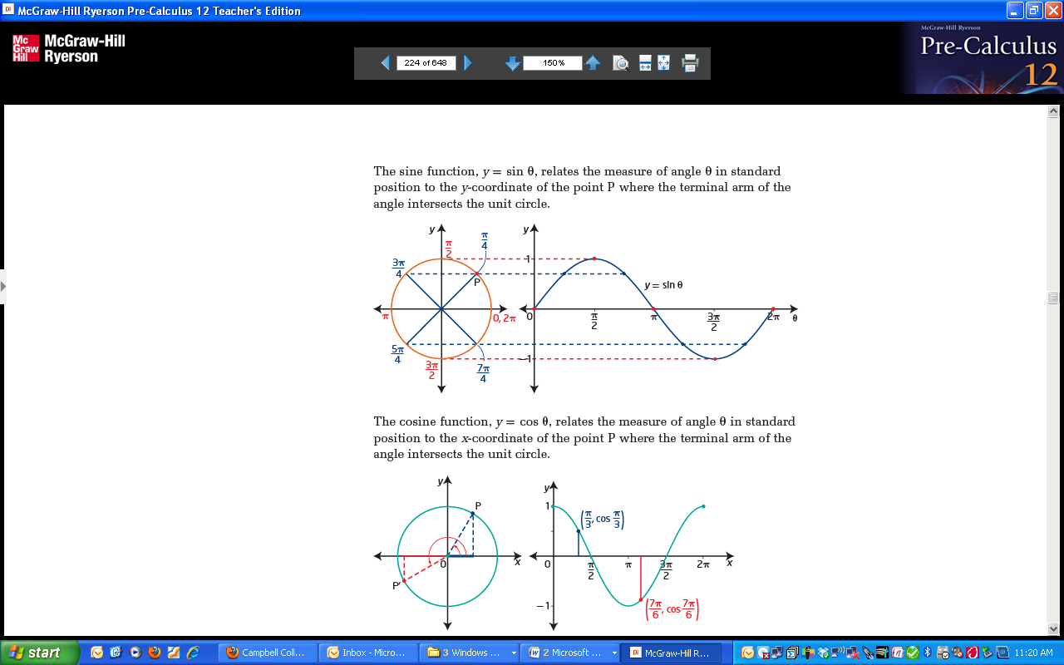**The Sine Function**

* The values of  can be transferred to a new view as shown in the video’s:
* The graph of the function repeats itself, so it is known as a **periodic function**.
* A sine graph is a graph of the function . It is also known as a **sinusoidal curve**.

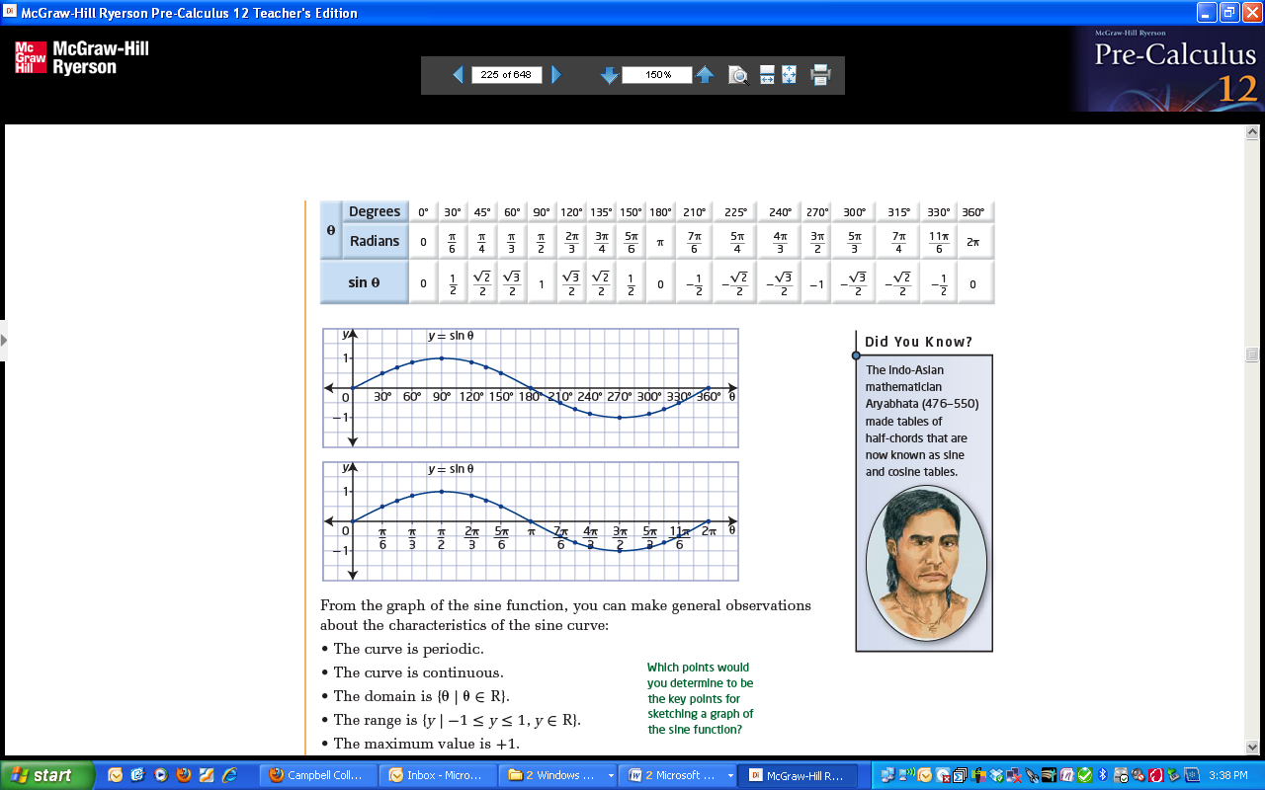

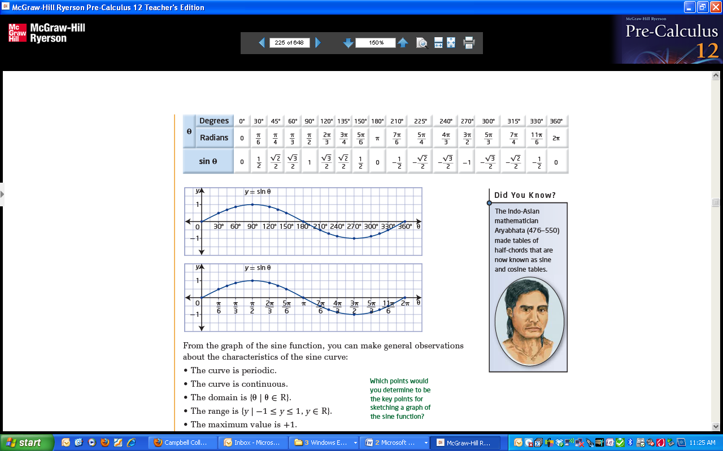

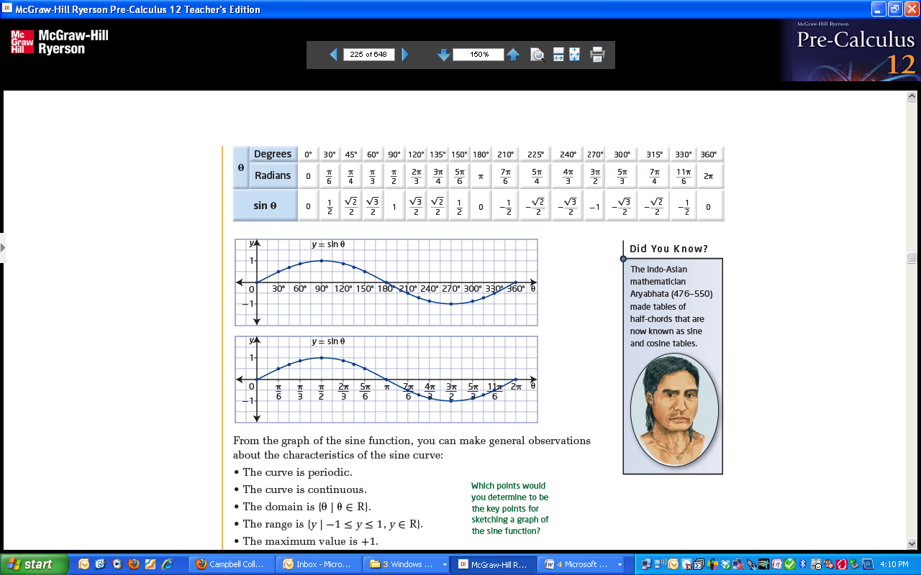

**IN RADIANS:**

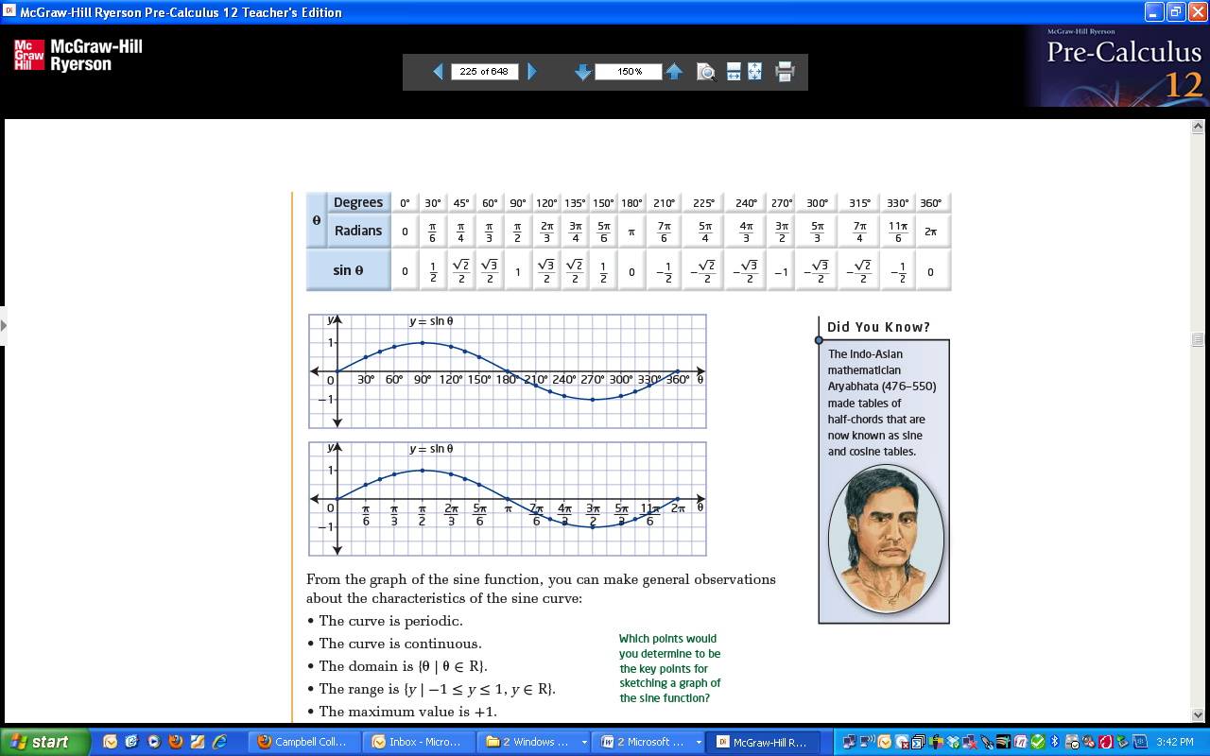

**IN DEGREES:**

* The graph/curve is **periodic** and **continuous**.
* The **domain** is
* The **range** is
* The **maximum** value is
* The **minimum** value is
* The **amplitude** (maximum vertical distance above or below the horizontal centre) is
* The **period** (the horizontal length of one cycle) is
* The ***y­*-intercept** is
* The **x-intercept(s)** on  are:

**The Cosine Function**

Complete the table of values for cos θ. Then label the graph of cos θ below.

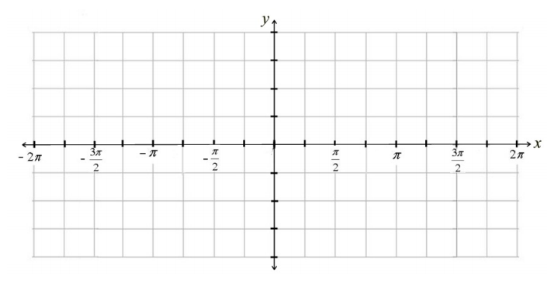

|  |  |  |  |  |  |  |  |  |
| --- | --- | --- | --- | --- | --- | --- | --- | --- |
| degrees | 0⁰ | 30⁰ | 45⁰ | 60⁰ | 90⁰ | 180⁰ | 270⁰ | 360⁰ |
| radians | 0 |  |  |  |  |  |  |  |
| Cos θ |  |  |  |  |  |  |  |  |



* How is the graph of similar to that of ?
* How is it different?

From the graph of the cosine function we can note the following observations:

* The graph is **periodic** and **continuous**.
* The **domain** is
* The **range** is
* The **maximum** value is
* The **minimum** value is
* The **amplitude** of the curve is
* The **period** is
* The ***y­*-intercept** is
* The **x-intercept(s) on** are:

Ex #1: Sketch the graph of y = sinx, 

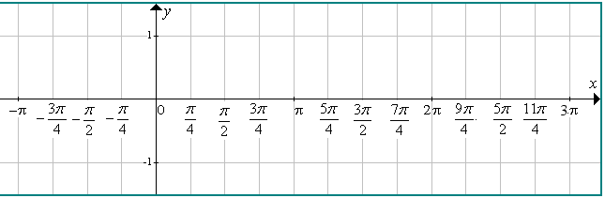

Ex #2: Sketch the graph of y = cosx, 

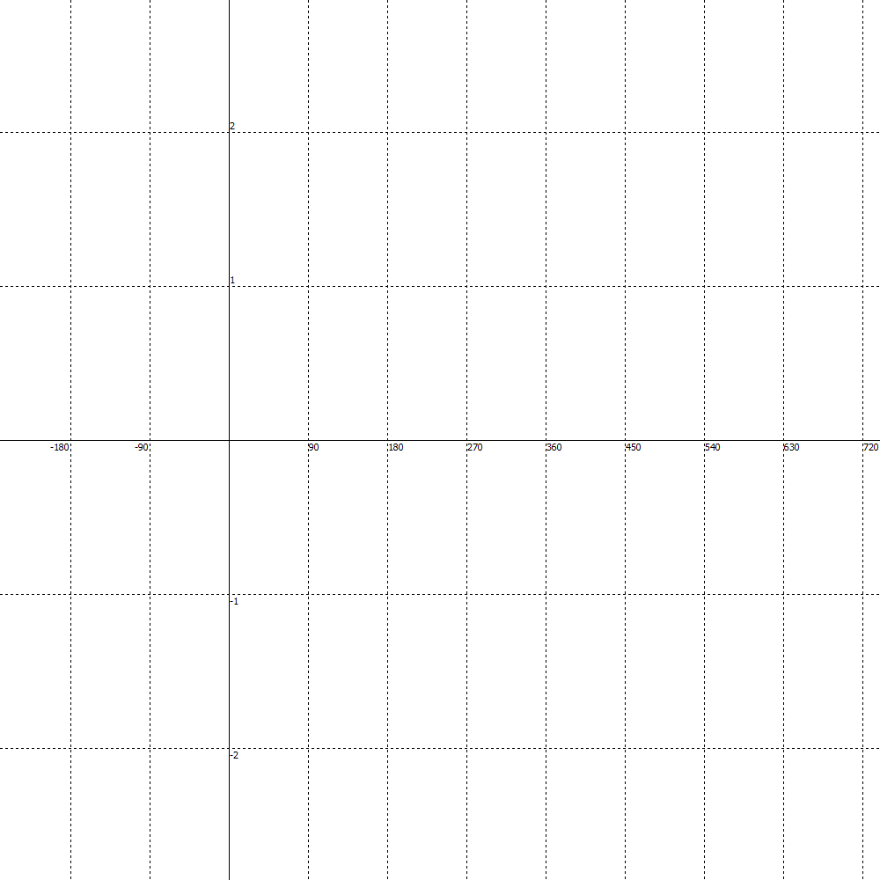

**Determining the Amplitude of a Sine or Cosine Function**

ACTIVITY:

* Using your phone (or sitting next to someone who has a device), go to desmos.com (or you may use another graphing calculator program or app)
* Graph the following: y = sinx (the sin will be in the funcs button). Describe the graph:
  + Leaving your original graph on the screen, type in y = 3sinx . What changes about the graph?
  + Now type in y = -3sinx. What changes?
  + Without graphing, what do you predict will happen if you type in y = ½ sinx?
* Repeat the above using cos instead of sin. How is the graph of y = cosx different from y = sinx?
* **Adding a coefficient in front of sinx or cosx will change the _________________________ of the graph. If the coefficient is negative, the graph will have a ________________________________________**
* **The AMPLITUDE of a graph is : **

 

**We know that any function in the form  is related to  by a vertical stretch by a factor of |a|. Remember that if *a* < 0, then the function must also be reflected in the *x*-axis.**

Ex #3: Using different colours, sketch the graph of y = -4sinx and y = -1.5 sinx . What is the amplitude of each?

**5.1 Day 1 ASSIGNMENT**

5.1 Day 1FA: P233 #3, 4, 7, 11

5.1 Day 1 ULA: P233 #12b, 18

5.1 Day 2: Graphing Sine and Cosine Functions

To graph the sine and cosine functions that involve transformations. To be able to determine the domain, range, max/min, amplitude, period and intercepts of sine and cosine.

ACTIVITY:

* Using your phone (or sitting next to someone who has a device), go to desmos.com (or you may use another graphing calculator program or app)
* Graph the following: y = sinx (the sin will be in the funcs button). Describe the graph:
  + Leaving your original graph on the screen, type in y = sin2x . What changes about the graph?
  + Now type in y = sin3x. What changes?
  + What changes if you graph ?
  + What changes if you graph 
* Do the same patterns hold if you repeat the activity using the cosine function??
* **The PERIOD of a function is the length of the interval over the domain over which a graph repeats itself. Another way to describe it is the horizontal length of one cycle on a periodic graph.**
* **Adding a coefficient, b, in front of the x in sinx or cosx will change the _________________________ of the graph.**
* **The period of the base function of y = sinx or y = cosx is  . This means that it will take a horizontal distance of  for the graph of y = sinx to form a complete shape or for the graph of y = cosx to form a complete shape**
* **Given an equation  or , the period for each will be a horizontal length of either  in radians, or  in degrees**

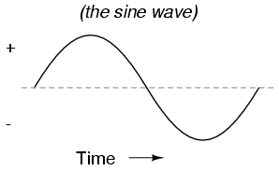

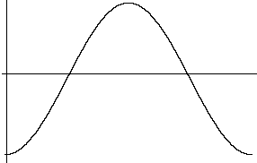

Ex #1: Determine the period length and amplitude of the following:

a) y=2cos2x b) y = -4sin3x c) 

Ex #2: Determine the amplitude and period length for y = 2cos2x. Draw a careful sketch of one positive period and one negative period.



* Identify the x and y intercepts:

Ex #3: Determine the amplitude and period length of  . Draw a careful sketch of one positive period and one negative period.



* Identify the x and y intercepts:

Ex #4: Given each of the following, determine:

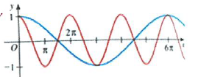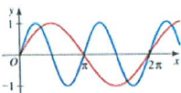i) ii)

a) Highlight and name the base function:

b) Looking at the second function state:

* The amplitude
* The value of *a*
* The period length
* The value of *b*
* The equation of the function

a) Highlight and name the base function:

b) Looking at the second function state:

* The amplitude
* The value of *a*
* The period length
* The value of *b*
* The equation of the function

**5.1 Day 2 ASSIGNMENT**

5.1 Day 2 FA: P233 #5, 6, 8-10, PLUS EXTRA QUESTIONS a - g BELOW

5.1 Day 2 ULA: P233 #14, 15 PLUS EXTRA QUESTIONS h-i below

**EXTRA QUESTIONS FOR 5.1 Day 2 FA**: (Do your work on looseleaf but graphs are provided on the next page)

Given the following, determine the amplitude, period length and draw a careful labelled sketch of the function over one positive and one negative period. ANSWERS WILL BE SENT OUT ON REMIND

a) y = 3cosx b)  c) y = -2cosx d)  e) 

f)  g)  h)  i) 







5.2: Transformations of Sine and Cosine Functions

To graph sine and cosine functions with vertical displacement and phase shifts.

**KEY IDEAS:**

**You can apply the same transformation rules to sinusoidal functions of the form:**

**y = a sin b(θ – h) + k or y = a cos b(θ – h) + k.**

* A **vertical stretch** by a factor of |a| **changes the amplitude** to |a|.

y = a sin θ y = cos θ

If a < 0, the function is reflected through the midline of the function.

* A **horizontal stretch** by a factor or  **changes the period** to , or radians.

y = sin(bθ) y = cos (bθ)

If b < 0, the function is reflected in the y axis.

* For sinuisoidal functions, a horizontal translation is called a **phase shift.**

y = sin (θ – h) y = cos (θ – h)

If h > 0, the function shifts h units to the right.

If h < 0, the function shifts h units to the left.

* The **vertical displacement** is a vertical translation. NOTE: 

y = sin θ + k y = cos θ + k

If k > 0, the function shifts k units up.

If k < 0, the function shifts k units down.

* The **sinusoidal axis is defined by the line y = k**. It represents the **midline of the function**.
* The domain of a sinusoidal function is not affected by transformations
* The range of a sinusoidal function, is affected by changes to the amplitude and vertical displacement

Ex #1: Determine the phase shift and vertical placement. Then graph one positive period of the function. Choose appropriate scales for the axes.

a)  Phase Shift: __________________ Vertical Displacement: __________________b)  Phase Shift: __________________ Vertical Displacement: __________________



Ex #2: Determine the key features of each sine function.

a) 

Amplitude: _________ Vertical Displacement: __________

Period: _________ Domain: _________

Phase Shift: __________ Range: _________

b) y = 0.1 sin (2θ + 90°) – 1

Amplitude: _________ Vertical Displacement: __________

Period: _________ Domain: _________

Phase Shift: __________ Range: _________

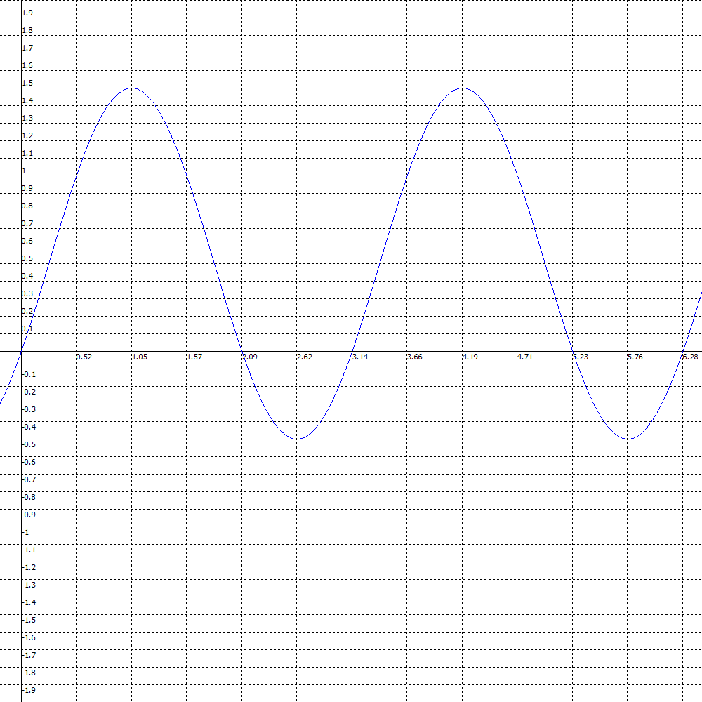

c)

Amplitude: _________

Period: _________

Phase Shift: __________

Vertical Displacement: __________

Domain: _________

Range: _________

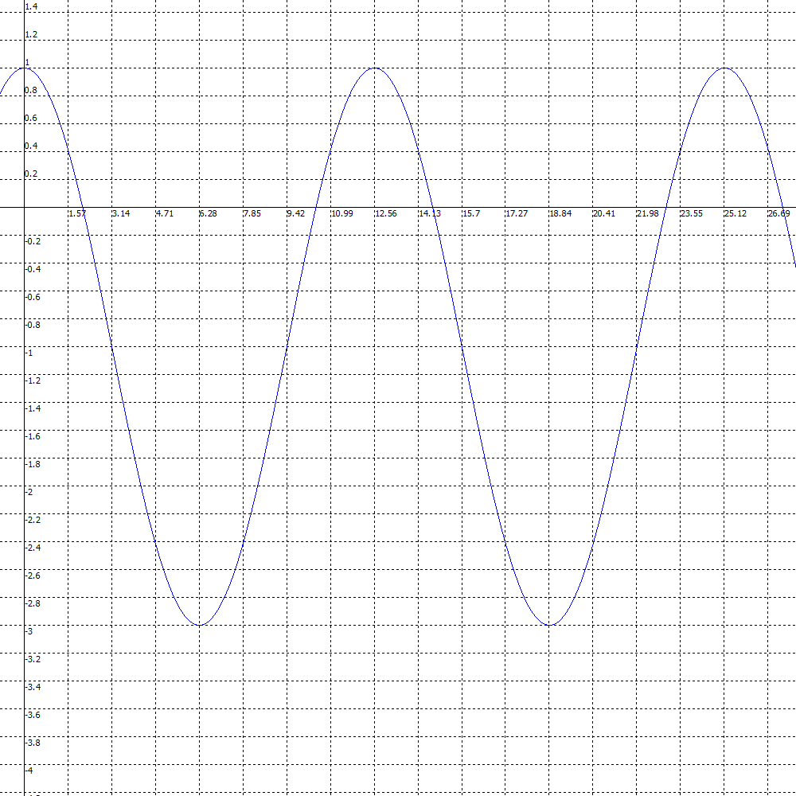d)

Amplitude: _________

Period: _________

Phase Shift: __________

Vertical Displacement: __________

Domain: _________

Range: _________

Day 1 Assignment: P 250 1abc, 2abc, 3, 5, 12ac,

Ex #3: Write the equation of each sine function in the form y = a sin b(x – h) + k, given its characteristics.

a) amplitude = 2, period π, phase shift π/3 to the left, vertical displacement 1 unit down.

b) amplitude = 1/4, period 6π, phase shift π to the left, vertical displacement 2 units up.

Ex #4: Graph each.Show at least two cycles.

a) y = 5 sin 0.5(θ + π) + 3



b) 



c) 

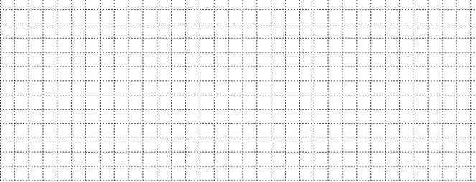

d) 



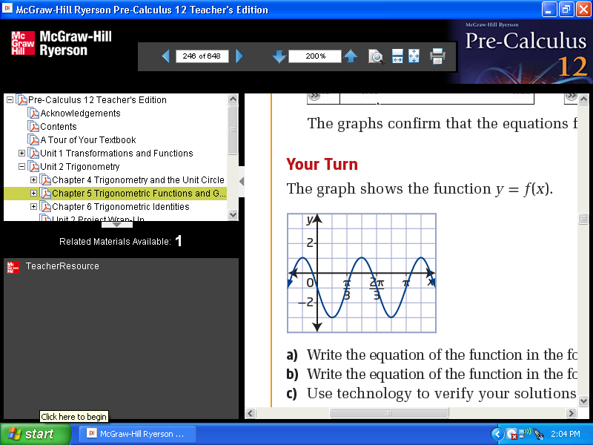Ex #5:

a) Write the equation of the function in the form , *a*> 0.

b) Write the equation of the function in the form , *a*> 0.

Ex #6:

Write an equation of the form y = a sin b(θ – h) + k and an equation of the form y = a cos b(θ – h) + k to represent the function graphed below.

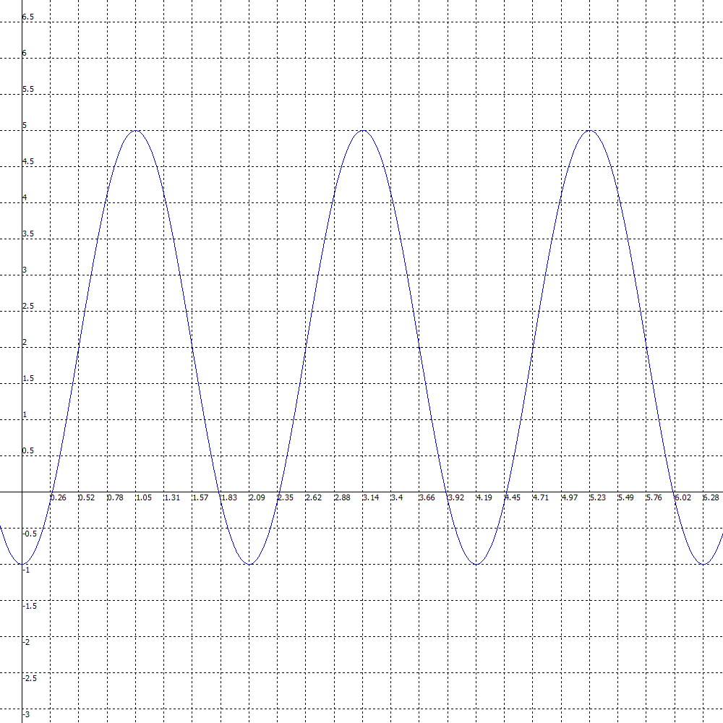

**5.2 ASSIGNMENT**

5.2 FA: P250

#1 (only sketch e&f), 2(only sketch ace), 3, 4, 5, 6, 7, 12ac, 14ab(i-v), 15, 16

5.2 ULA: P250 #8, 9, 10a, 11, 19a, 20, 24a-d

1abc, 2abc, 3, 5, 12ac,







5.4: Equations & Graphs of Trig Functions

To solve problems that apply trig functions.

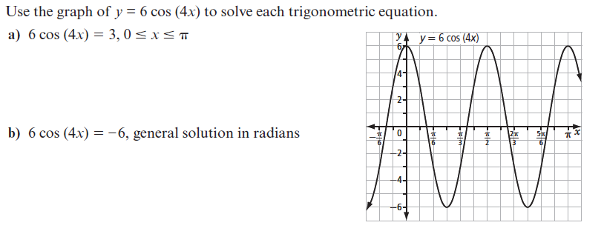Trigonometric functions are frequently used to model real life occurrences that are cyclic or periodic such as water depth due to tides, population growth, electricity, sound waves, etc. They can also be used to represent shapes that look like the curve such as roller coasters, water slides, etc.  
 Ex #1: Solve the following both algebraically and graphically.



Ex #2: The population of water buffalo is given by  where *t* is the number of years since the first estimate was made.



a) Draw a sketch of the graph

b) What was the initial estimate?

c) What was the population after 2 years?

d) What is the period of this function?

d) Find the smallest population size and when it first occurs.

Ex #3: The Singapore Flyer is the world’s tallest Ferris wheel. People ride the wheel in capsules. The wheel has a diameter of 150 m and completes one revolution in approximately 32 min. A capsule reaches a height of 165 m.

a) Determine a function that models the height, h metres, of a capsule at any time t minutes after the wheel begins to rotate. Sketch.



b) Assume a capsule is at the base of the wheel when it begins to rotate. Sketch the function. What is the height of the capsule 20 min after the wheel begins to rotate?

**5.4 ASSIGNMENT**

5.2 FA: P276 #6, 9, 10, 12, 15ab, 19ab

5.3: The Tangent Function

To graph the tangent function and determine its amplitude, domain, range and period.

Ex #1:  **Use the unit circle and a table of values to graph tangent.**

* Remember that  and that 
  + The tangent ratio of the angle IS the slope of the terminal arm!

|  |  |
| --- | --- |
|  |  |
| 0 |  |
|  |  |
|  |  |
|  |  |
|  |  |
|  |  |
|  |  |
|  |  |
|  |  |
|  |  |
|  |  |
|  |  |
|  |  |

|  |  |
| --- | --- |
|  |  |
| 0 |  |
| - |  |
|  |  |
| - |  |
|  |  |
| - |  |
| - |  |
| - |  |
|  |  |
| - |  |
|  |  |
| - |  |
| - |  |

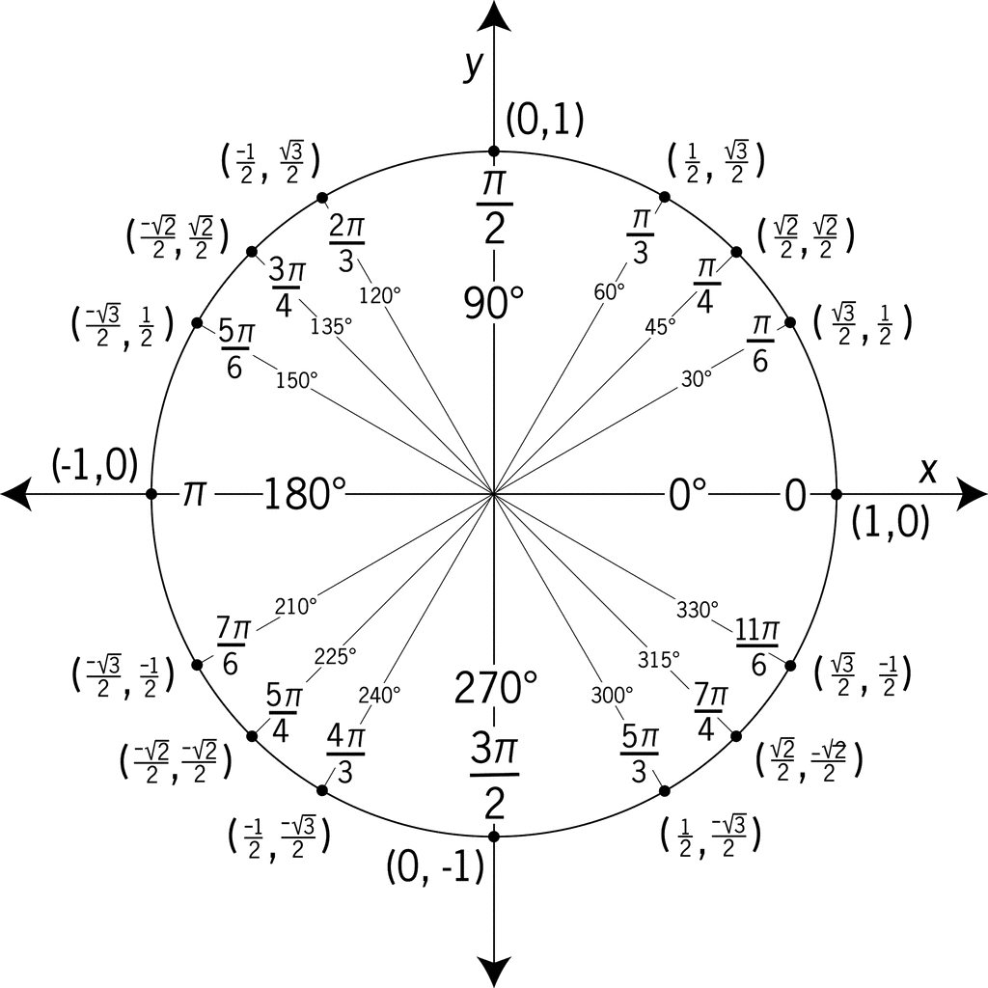



<https://goo.gl/sRmEh>

**KEY IDEAS FOR THE GRAPH OF TANGENT:**

* The graph of  has a period of ___________
* The graph of  has an amplitude of ___________
* The graph of  has a domain of ____________________________________
* The graph of  has a range of of _________________
* The curve of the graph is not continuous. It has asymptototes at ___________________ because at this point the function is undefined
* The tangent function is undefined whenever________= 0 because:
* The tangent function has x intercepts at ____________________
* The tangent function has a y intercept at________________
* You can sketch one cycle of the tangent function beginning at the *y*-intercept or you can use the asymptotes for the beginning and end of a cycle.
* The use of the word tangent will be very important in Calculus. The ***tangent line*** or ***tangent*** to a curve is a line that touches a curve, or a graph of a function, at a single point.



Ex #2: A small plane is flying at a constant altitude of 6000 m directly toward an observer. Assume that the ground is flat in the region close to the observer.

**a)** Determine the relation between the horizontal distance, in metres, from the observer to the plane and the angle, in degrees, formed from the vertical to the plane.

**b)** Sketch the graph of the function.



**c)** Where are the asymptotes located in this graph? What do they represent?

**d)** Explain what happens when the angle is equal to 0°.

**5.3 ASSIGNMENT**

5.3 FA: P262 #2, 3

5.3 ULA: P262 #8, 11

LIST OF VIDEOS THAT MAY AIDE IN UNDERSTANDING

[Section](https://www.carlton.srsd119.ca/wordpress/index.php/students/departments/math/video-lessons/math-30c-pre-calculus-video-lessons/1a-transforming-functions/) 5.1

<https://goo.gl/pz7wR1>

<https://goo.gl/scYg3K>

[Section](https://www.carlton.srsd119.ca/wordpress/index.php/students/departments/math/video-lessons/math-30c-pre-calculus-video-lessons/1a-transforming-functions/) 5.2

<https://goo.gl/EQR3N2>

<https://goo.gl/4iaecq>

[Section](https://www.carlton.srsd119.ca/wordpress/index.php/students/departments/math/video-lessons/math-30c-pre-calculus-video-lessons/1a-transforming-functions/) 5.3

<https://goo.gl/a5JiDb>

<https://goo.gl/xecByD>

[Section](https://www.carlton.srsd119.ca/wordpress/index.php/students/departments/math/video-lessons/math-30c-pre-calculus-video-lessons/1a-transforming-functions/) 5.4

<https://goo.gl/ra9pSz>

SOLUTIONS TO 5.1 DAY 2 EXTRA QUESTIONS

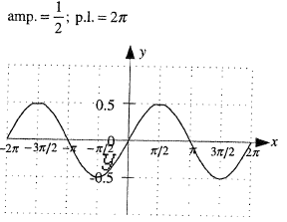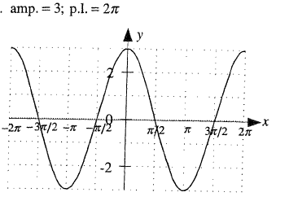

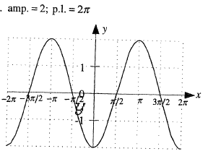a) b) c)

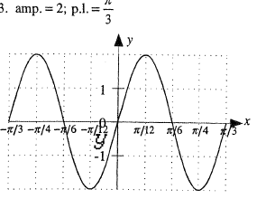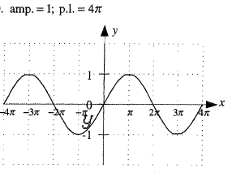

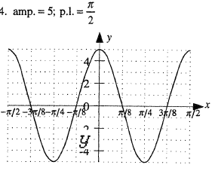d) e) f)

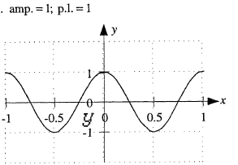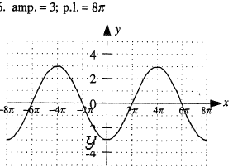

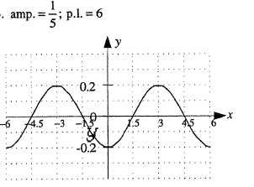g) h) i)