**Review for Comprehensive Test #1 on Wed. April 3**

**Topic 1 - System of Linear Inequalities ( Ch. 6) EXTRA = Extra questions on the back relating to that concept**

|  |  |  |
| --- | --- | --- |
| **Concept #** | **Concept** | **Review Questions** |
| 1 | 6. 1 Graph , determine and verify algebraically the solution to a single linear inequality | **Pg 349 #1 Pg 520 #1,2** |
| 2 | 6.2/3 Graph a system of linear inequalities, find and verify solutions. Also be able to write a system of inequalities given a graph. | **Pg 323 #5a, Pg 349 #6** |
| 3 | 6.2/3 Write an inequality or a system of inequalities to match a given situation, find its domain, range and restrictions, graph the system, find a solution and be able to describe what the solution represents. | **Pg 349 #3 Pg 304 #7,9 Pg 318 #6,8** |
| 4 | 6.4-6.6 Solve an optimization problem given just the situation. Justify and explain feasible regions, coordinates of vertices and other parts of optimization problems | **Pg 347 #3, 4, Pg 350 #11 Pg 520 #3 EXTRA** |

**Topic 2- Quadratic Functions( Ch. 7)**

|  |  |  |
| --- | --- | --- |
| **Concept #** | **Concept** | **Review Questions** |
| 5 | 7.2 Be able to graph a quadratic function using a table of values | **Pg 443 #1 Pg 370 #7ab** |
| 6 | 7.2 Given the graph of a quadratic function in standard form find the: vertex, equation of the axis of symmetry, domain and range and max or min.  7.2 Given the x- intercepts or two symmetrical points find the equation of the axis of symmetry. | **EXTRA** |
| 7 | 7.5 Solve a quadratic equation by factoring( Determine the roots) and graph | **Pg 520 #4 Pg 521 #10 Pf 443 #8** |
| 8 | 7.4 Write a quadratic equation in standard form given the zeros/x-intercepts or graph of a quadratic function. | **Pg 521 #7 Pg 440 #4** |
| 9 | 7.7 Solve a quadratic equation using the quadratic formula/determine the x intercepts of a parabola using the quadratic formula | **Pg 444 #13 Pg 428 #4, 6** |
| 10 | 7.5/7.7/7.8 Solve a situational problem modelled by a quadratic function with or without a graphing calculator in standard form | **Pg 521 #11 Pg 440 #3, 8**  **Extra** |
| 11 | 7.6 Given Vertex form determine: vertex, x and y intercepts, domain and range, equation of the axis of symmetry, opens up or down, max or min and then be able to graph. | **Pg 520 #5 Pg 443 #9** |
| 12 | 7.6 Determine the equation in vertex form of a parabola given its graph | **EXTRA** |
| 13 | 7.6 /7.8 Solve a situational problem modelled by a quadratic function using vertex form.( Including domain and range implications) | **Pg 444 #12 Pg 437 #5** |

**Topic 3 – Inductive and Deductive Reasoning (Ch.1)**

|  |  |  |
| --- | --- | --- |
| **Concept #** | **Concept** | **Review Questions** |
| 14 | 1.1 Make a conjecture by observing patterns and identifying properties | **Pg 110 #1, 5a, 7** |
| 15 | 1.2/3 Analyze an argument for its validity and provide counterexamples to a conjecture with false conclusions | **Pg 110 #3 Pg 61 #5,6, 7** |
| 16 | 1.4/5 Prove algebraic number relationships and conjectures and identify errors in proof | **Pg 110 #5b, 6, 8 Pg 61 #9 -13** |

**Extra Practice Questions:**

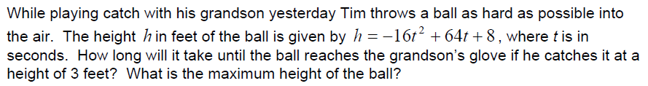 **Concept #10 (May use graphing calculator or solve algebraically)**

a)

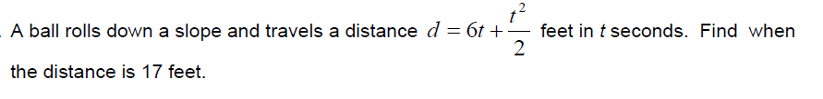

b)

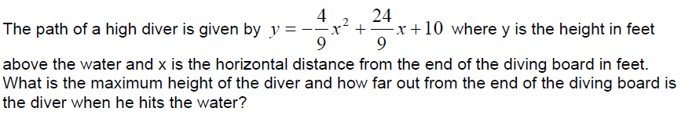

c)

**Concept #4**

a) The stylists in a hair salon cut hair for women and men.

• The salon books at least 5 women’s appointments for every man’s appointment.

• Usually there are 90 or more appointments, in total, during a week.

• The salon is trying to reduce the number of hours the stylists work.

• A woman’s cut takes about 45 min, and a man’s cut takes about 20 min.

What combination of women’s and men’s appointments would minimize the number of hours the stylists work? How many hours would this be?

b) On a flight between Calgary and Thunder Bay, there are business class and economy seats.

• At capacity, the airplane can hold no more than 133 passengers.

• No fewer than 124 economy seats are sold, and no more than 5 business class seats are sold.

• The airline charges $624 for business class seats and $239 for economy seats.

What combination of business class and economy seats will result in the maximum revenue? What will this maximum revenue be?

c) A zoo has categorized its exhibits as herbivores and carnivores.

• There are no more than 80 exhibits altogether.

• No more than 75% of the exhibits are herbivores, and no less than 40% are carnivores.

• A ticket to any herbivore exhibit costs $10, and a ticket to any carnivore exhibit costs $12.

What combinations of herbivore and carnivore exhibits would maximize the zoo’s revenue?

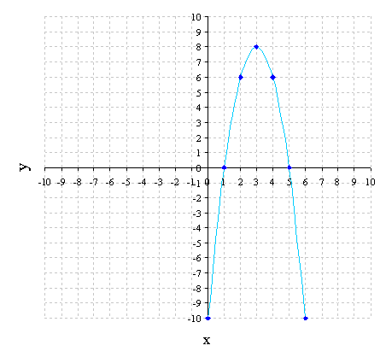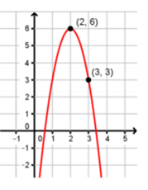**Concept # 12** a) Determine the equation in vertex form **Concept #8** a) Determine the quadratic function of the following graph in standard form

**Concept #6**

a) Using the graph from concept #8(a) find the following:

**Solutions to EXTRAS**

Concept #10a) 4.077 secs ; 72 ft b) 2.367 secs c) 14 ft; 8.612 ft

Concept #12 a) 

Concept #8 a) 

Concept #6 a) vertex (3,8) ; x=3 ;  ;  ; Max at 8

b) i) x = -3 ii) x = 

Vertex:

Equation of axis of symmetry:

Domain:

Range:

Max or min? Value?

b) For each of the following, both points are located on the same parabola.

Determine the axis of symmetry

i) ( 3, 6) and ( -9, 6) ii) (  ) and ( )

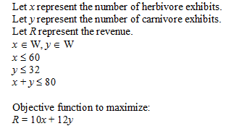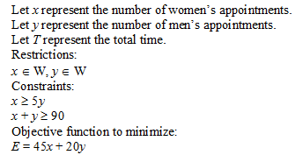**Concept #4( Solutions)** a) c)

If there were 48 herbivore exhibits and 32 carnivore exhibits this would maximize the zoo’s revenue with a profit of $864.

would maximize the zoo’s revenue , giving them a revenue of $864.

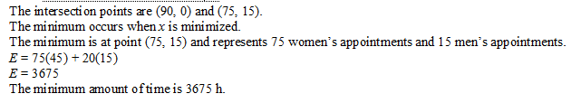

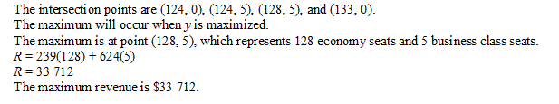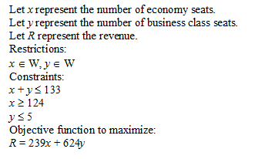b)