**Review for Comprehensive Test #1 on Friday Oct. 19**

**Topic 1- Fun with Factoring Ch.3 (3.1-3.2) Note: An approved calculator will be allowed for the Test.**

|  |  |  |
| --- | --- | --- |
| Concept # | Concept | **Review Questions** |
| 1 | 3.1 Determine the greatest common factor of whole numbers using prime factorization  **(Skill)** | **Pg 252 #7** |
| 2 | 3.1 Determine the least common multiple of whole numbers using prime factorization  **(Skill)** |
| 3 | 3.2 Determine and explain if a whole number is a perfect square or perfect cube and determine its square root or Cube root  **(Skill)** | **Pg 149 #8** |
| 4 | 3.1/3.2 Solve problems that involve prime factors, greatest common factors, least common multiples, square roots or cube roots**(Problem Solving)** | **Pg 252 #8 Pg 140 #13,17,19 Pg 149#5** |

**Topic 2 – Exponents and Irrational Numbers Ch.4 (4.1-4.6)**

|  |  |  |
| --- | --- | --- |
| Concept # | Concept | **Review Questions** |
| 5 | 4.2 Classify numbers – sort a set of numbers into rational and irrational numbers and describe which subsets of the Real numbers it belongs to: natural, whole, integers, rational and irrational.  **(Skill)** | **Pg 246 #6 , Pg 211 #4** |
| 6 | 4.2 Order a set of real numbers (rational & irrational)**(Skill)** | **Pg 246 #9 pg 253 #19,20** |
| 7 | 4.3 Write a radical as a mixed radical in simplest form (limited to numerical radicands – no variables) and mixed radical as an entire radical  **(Skill)** | **Pg 253 #21** |
| 8 | 4.4 Express powers with rational exponents as radicals and vice versa **(Skill)** | **Pg 253 #22** |
| 9 | 4.5 Evaluate powers with negative integer exponents, negative rational exponents, an exponent of zero **(Skill)** | **Pg 253 #23** |
| 10 | 4.6 Simplify expressions by applying the exponent laws ( including expressions with variable bases)  **(Skill)** | **Pg 253 #25,26** |

**Topic 3 – Measurement Ch.1 ( 1.1-1.7)**

|  |  |  |
| --- | --- | --- |
| Concept # | Concept | **Review Questions** |
| 11 | 1.1/1.3 Correctly convert from imperial to SI or SI to imperial (linear measurements)  **(Skill and Problem Solving)** | **Pg 130 #1,4,5** |
| 15 | 1.4 / 1.6 Determine the surface area of 3D objects (right cones, cylinders, prisms, pyramids and spheres) **(Skill and Problem Solving)** | **Pg 130 #6-9, 10,12,13**  **Pg 458 #2 pg 252 #3** |
| 16 | 1.5/1.6 Determine the volume of 3D objects (right cones, cylinders, prisms, pyramids and spheres) **(Skill and Problem Solving)** |
| 17 | 1.7 Determine the surface area and volume of composite objects **(Skill and Problem Solving)** | **pg 130 #11 Pg 66 #25, 26 Pg 67 #4** |

**Area Volume Surface Area**

Rectangle = *lw* Prism = (*area of base*)*h* Prism = Sum of the areas of each face

Circle = *πr* 2  Cylinder =  Cylinder = 

Triangle =  Cone =  Cone = 

Parallelogram =  *bh* Pyramid =  Sphere = 

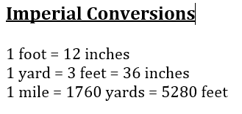Trapezoid =  Sphere =  Pyramid = Sum of the area of the base and the areas of the triangular faces

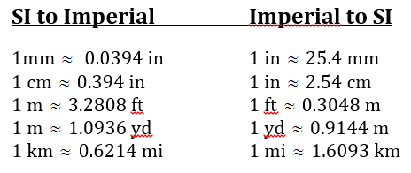

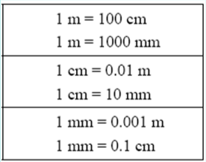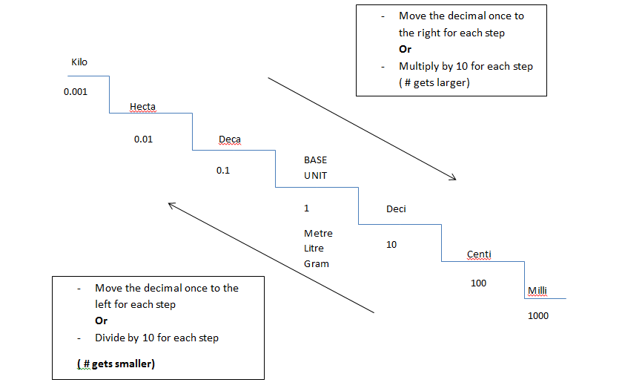

**Circumference of a circle=**

 or 