**Review for Comprehensive Test #1 on Friday Oct. 19, 2018**

This will be a comprehensive test that covers Topics 1-3 ( Ch. 3.1,3.2, Ch.4 and Ch.1) Note: You will be allowed a calculator and formula sheet (found on back)

**Topic 1- Fun with Factoring Ch.3 (3.1-3.2)**

|  |  |  |
| --- | --- | --- |
| Concept # | Concept | **Review Questions** |
| 1 | 3.1 Determine the greatest common factor of whole numbers | **Pg 252 #7** |
| 2 | 3.1 Determine the least common multiple of whole numbers |
| 3 | 3.2 Determine and explain if a whole number is a perfect square or perfect cube and determine its square root or Cube root | **Pg 149 #8** |
| 4 | 3.1/3.2 Solve problems that involve prime factors, greatest common factors, least common multiples, square roots or cube roots | **Pg 252 #8 Pg 140 #13, 22 Pg 149#5, 10 Pg 198 #10** |

**Topic 2 – Exponents and Irrational Numbers Ch.4 (4.1-4.6)**

|  |  |  |
| --- | --- | --- |
| Concept # | Concept | **Review Questions** |
| 5 | 4.2 Classify and order numbers – sort a set of numbers into rational and irrational numbers and describe which subsets of Real numbers it belongs to: natural, whole, integers, rational, irrational and order them on a number line | **Pg 246#6,7 pg 253 #19, 20** |
| 6 | 4.3 Write a radical as a mixed radical in simplest form and mixed radical as an entire radical | **Pg 253 #21 Pg246#11, 12, 14** |
| 7 | 4.4 Express powers with rational exponents as radicals and vice versa | **Pg 253 #22** |
| 8 | 4.5 Evaluate powers with negative integer exponents, negative rational exponents, an exponent of zero | **Pg 253 #23** |
| 9 | 4.6 Simplify expressions by applying the exponent laws ( including expressions with rational and variable bases) | **Pg 253 #25,26** |

**Topic 3 – Measurement Ch.1 (1.1-1.7)**

|  |  |  |
| --- | --- | --- |
| Concept # | Concept | **Review Questions** |
| 10 | 1.1/1.3 Correctly convert from imperial to SI or SI to imperial (linear measurements) | **Pg 130 #1,4,5 Pg 458 #1** |
| 11 | 1.4 / 1.5/1.6Determine the surface area of 3D objects (right cones, cylinders, prisms, pyramids & sphere’s) | **Pg 130 #6-9, 11,12**  **Pg 458 #2ab**  **Pg130#10,13**  **Pg 252 #1,2,3 Pg 458 #2** |
| 12 | 1.5/1.6 Determine the volume of 3D objects (right cones, cylinders, prisms, pyramids & sphere’s |
| 13 | 1.7 Determine the surface area and volume of and composite objects | **Pg 66 #25, 26 Pg 67#4** |

NOTE: IF you feel you need more practice on any of the above topics please refer to both the Foundational and Mid Level Assignments from each lesson!!!!

**Area Volume Surface Area**

Rectangle = *lw* Prism = (*area of base*)*h* Prism = Sum of the areas of each face

Circle = *πr* 2  Cylinder =  Cylinder = 

Triangle =  Cone =  Cone = 

Parallelogram =  *bh* Pyramid =  Sphere = 

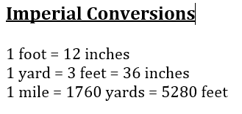Trapezoid =  Sphere =  Pyramid = Sum of the area of the base and the areas of the triangular faces

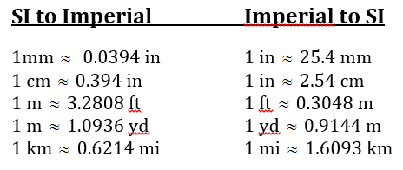

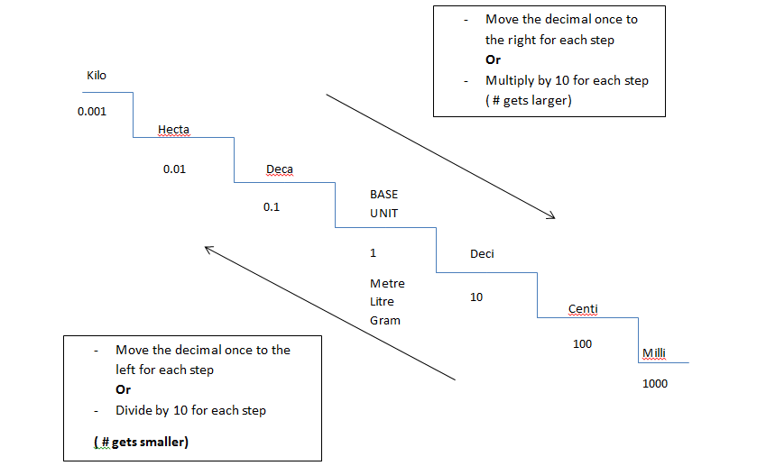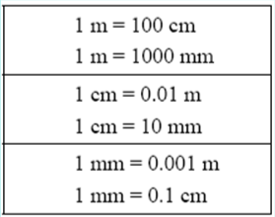

**Circumference of a circle=**

 or 