Course Outline: Pre-AP Foundations & PreCalculus 10
Fall 2018 Semester

Teacher: Ms. Darla Carignan
Email: Darla.carignan@rbe.sk.ca
General Course Description
Foundations of Mathematics and Pre-Calculus 10 (FM10) is an introductory course offered to prepare students for one of two possible strands of high school Mathematics. This course is a prerequisite for Foundations of Mathematics 20 and Pre-Calculus 20. This course is one that will be more difficult and move at a quicker pace than Mathematics 9. Much of the material has been introduced in Math 9 and is taken more in-depth here at the grade ten level.

Students are encouraged to visit my website for class information, extra help, math videos & supplementary materials: http://carignanmath.weebly.com

Outcome for Chapter Sections 3.1 & 3.2: (Concepts 1-4)
- FP10.1: Demonstrate understanding of factors of whole numbers by determining the prime factors, the greatest common factor, the least common multiple, the principal square root and the cube root.

Outcome for Chapter Sections 4.1 – 4.6: (Concepts 5-10)
- FP10.2: Demonstrate understanding of irrational numbers in both radical (including mixed radical) and exponent

Outcome for Chapter Sections 1.1-1.7: (Concepts 11-14)
- FP10.3: Demonstrate understanding of SI and imperial units of measurement including linear measurement, surface area of spheres, and right cones, cylinders, prisms, and pyramids, volume of spheres, and right cones, cylinders, prisms, and pyramids and relationships between and within measurement systems.

Outcome for Chapter Sections 2.1 – 2.7: (Concepts 15-18)
- FP10.4: Develop and apply the primary trigonometric ratios (sine, cosine, tangent) to solve problems that involve right triangles.

Outcome for Chapter Sections 3.3 – 3.8: (Concepts 19-23)
- Outcome: FP10.5: Demonstrate understanding of the multiplication and factoring of polynomial expressions

Outcome for Chapter Sections 5.1 – 5.5: (Concepts 24-27)
- FP10.6: Expand and apply understanding of relations and functions

Outcome for Chapter Sections 6.1 – 6.2, 5.2, 5.6, 5.7: (Concepts 28 – 34)
- FP10.7: Demonstrate, with and without the use of technology, understanding of slope
- FP10.8: Demonstrate understanding of linear relations

Outcome for Chapter Sections 6.3 – 6.6 : (Concepts 25-40)
- FP10.9: Demonstrate understanding of the writing and application of equations of linear relations.

Outcome for Chapter Sections 7.1 – 7.6 : (Concepts 41-44)
- FP10.10: Solve problems that involve systems of linear equations in two variables, graphically and algebraically.

Evaluation:

Extension & Application Tasks & Projects 10%
Concept Checks (44 Concepts) 50%
Comprehensive Test #1 (FP 10.1, 10.2, 10.3) 10%
Comprehensive Test #2 (FP 10.4, 10.5, 10.6) 10%
Comprehensive Test #3 (FP 10.7, 10.8, 10.9, 10.10) 10%
Final Exam 10%
TOTAL 100%

ASSESSMENT & EVALUATION:

Please take some time to familiarize yourself with the assessment strategy used by the team of PreAP Foundations 10 teachers in all PreAP Foundations 10 courses. Here are the basics:

CONCEPT CHECK:
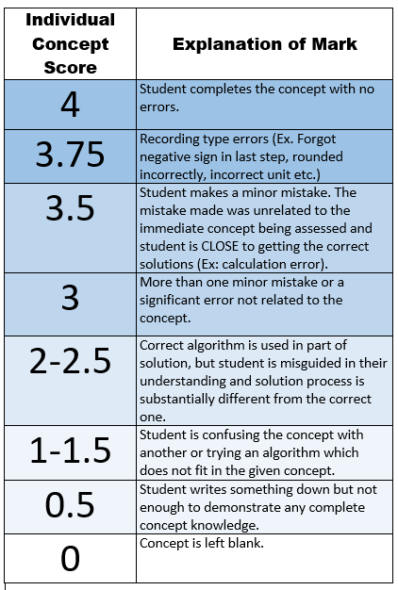
- The course is broken down into 40 concepts (the list of concepts is available on the website). Approximately once a week you will have a quiz on a selection of concepts. This quiz is called a Concept Check.
- Each concept on the quiz is tested using an appropriate number of questions that covers all aspects of the concept. Each concept is marked on a four point rubric (shown to the left).
- If you get a score of 3 or 3.5, you made one or more “minor or silly mistakes”. This mark indicates that we feel you understand the concept but are having computational problems or are missing steps or components that need to be shown.
- If you get a score of 2 or 2.5 we feel that you are having conceptual problems and are not fully understanding the meaning of the concept or how it is applied.
- If you get a score less than 2 we feel that you are not currently able to demonstrate understanding of the concept. You are showing some math in an answer but it isn’t the math that applies to the particular concept being tested.
- The Concept Check Quizzes contain the Foundational material that is necessary to be successful in this class AND in subsequent math classes. We place high value on students understanding these concepts fully and retaining this knowledge. With this in mind, there will always be two in class opportunities to assess each outcome in a Concept Check Quiz.

2nd ATTEMPTS FOR CONCEPTS:
- Concept Check #1 will test Concepts 1-5. After writing this Concept Check you will receive a mark for each concept out of 4. Concept Check #2 will test concepts 1-5 again and will test concepts 6-10 for the first time. We want you to learn from your mistakes so we give you the second try in order to clear up any problems you had the first time you wrote your quiz. We want you to be able to retain and truly understand the concept rather than memorizing. This means that we will always count your second mark on each concept as the summative mark.
NOTE:
    - If time permits, we may offer an out of class third attempt at concepts if appropriate.
    - Concept checks make up 50% of the course. In order to be a successful AP student it is imperative that the skills in these concepts are thoroughly understood and mastered during this course, thus the rationale for allowing for redo’s for 50% of the assessments.
NOTE: If you receive a mark less than 2 on a SKILL BASED Concept you MUST have completed the Foundational Assignment(s) for that concept in order to be eligible to have a second attempt at the concept. See below for a description of Foundational Assignment(s). If you receive a mark less than a 2 on a PROBLEM SOLVING BASED Concept you MUST have attempted at least half of the Upper Level Assignment for that concept.

COMPREHENSIVE TESTS
- Rather than Unit Tests, there will be three Comprehensive Tests during the semester. The Comprehensive Tests will focus on applying the skills learned in Concept Check Quizzes. Each Comprehensive Test will be worth 10%

EXTENSION & APPLICATION TASKS & JOURNALS
- There will be several take home Extension Assignments and Journal writing assignments that correlate with the concepts learned in this course. There will be an increased focus on proper mathematical and algebraic procedure and setup along with an expectation of detailed written explanation of the steps and solution.

DAILY WORK: FOUNDATIONAL ASSIGNMENTS & UPPER LEVEL ASSIGNMENTS
One of the most important things you can do to be successful in this class is to do your daily work. Most days I will give you and assignment that is broken into three parts:
- The first part of each daily assignment is the Foundational Assignment (FA). This assignment contains the fundamental questions that cover the basic foundation of the concept, and will cover the minimum of skills needed to pass the class. This assignment counts for formative marks on a daily basis and counts towards the incentive. Completing this assignment will help you to earn up to a 60% average in this class. These assignments will be due to be handed in for formative evaluation. These assignments must be labelled properly, be neatly completed and show all appropriate work in order to receive credit.
- The second part of the assignment is called the MID LEVEL ASSIGNMENT (MLA). This assignment contains higher level questions which will provide you with practice questions that are necessary to understand if you wish to get a mark above a minimum of 60%, as well as extra practice at Foundational Level Questions. Homework checks on this homework will be conducted and recorded on a regular basis but will not be counted towards the incentive.
- The last level of the assignment is called the UPPER LEVEL ASSIGNMENT (ULA). This assignment contains stretch and extension questions that will help students prepare for upper level math classes such as AP. Students who are motivated to do well in AP are encouraged to work on these questions throughout the semester. It is often advisable to work on these questions collaboratively with other students. Homework checks will not be done on these questions but they may be discussed in class.

CLASSROOM EXPECTATIONS:
- If you don’t understand the way something has been taught I can usually teach it in a couple several different ways – just ask!
- My classroom is a place where people feel comfortable and accepted. Please behave in ways that help make that true.
- Phone use: During teaching time, phones must either be left in your locker or placed in your slot in the phone holder at the front of the classroom. On most days you will be allowed to retrieve your phone after I am done teaching. This privilege will be removed if you choose to use your phone inappropriately in class.
  - Phones will NEVER be allowed during tests so be sure to always have your graphing calculator with you! I do not usually have extra calculators so you must come prepared.
- Extra help: Please always ask if you have any questions. Campbell Collegiate Math Teachers also provide a scheduled math help session every day – please check the posted sign in my classroom for times and locations
- There is no such thing as a stupid question! Ask if you don’t understand!!!!!!!
- You must come prepared for class – bring all supplies and your textbook every day.

SUPPLIES:
Organization: The more organized you are the better you will do in this class!
- Loose Leaf
- Graph Paper
- Binder
- Highlighters

- Coloured Pens
- Ruler
- Pencils
- Sticky Notes

- Eraser
- Approved Scientific Calculator (See Below)
- Graphing Calculator (See below)

- You MUST have a Scientific Calculator. Note: SCIENTIFIC CALCULATORS WITH THE FOLLOWING FEATURES WILL NOT BE ALLOWED:
  - WriteView
  - Mathprint
  - Multiview
  - Natural Display
  - Textbook Display

- A Texas Instrument Graphing Calculator will be used in order to complete various Pre-AP portions of this course (and for each subsequent Pre-AP and AP Math course). It is REQUIRED for grade 12 AP Calculus as the AP final exam in grade 12 is written using the graphing calculator for half the test and no access to any calculator for the other half. Below are photos of some of the types and varieties that will meet the needs of the students. It is recommended to purchase this Calculator at the grade 10 level if possible.
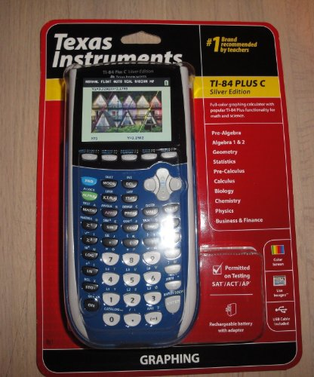
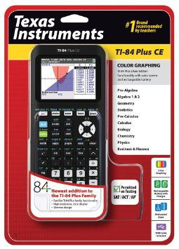
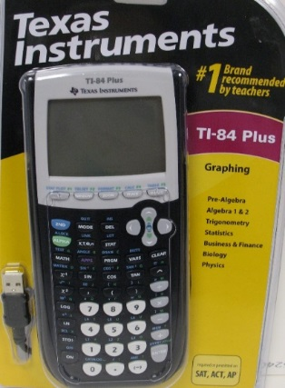

TI-84 Plus
- Regular black or Silver Case
- This calculator has a black and white screen and uses replaceable batteries
TI-84 Plus CE
- The case comes in various colours
- This Calculator has a coloured screen and a rechargeable battery
- It is thinner and lighter than the previous two models
TI-84 Plus C
- The case comes in various colours
- This Calculator has a coloured screen and a rechargeable battery

I use the Remind APP to send out homework assignments, answer keys to assignments and reminders about upcoming Concept Checks or Comprehensive Tests. It is very important that all students sign up for REMIND. Please use the following code to sign up now (Please use your actual name to sign up for Remind so that I know who you are!)

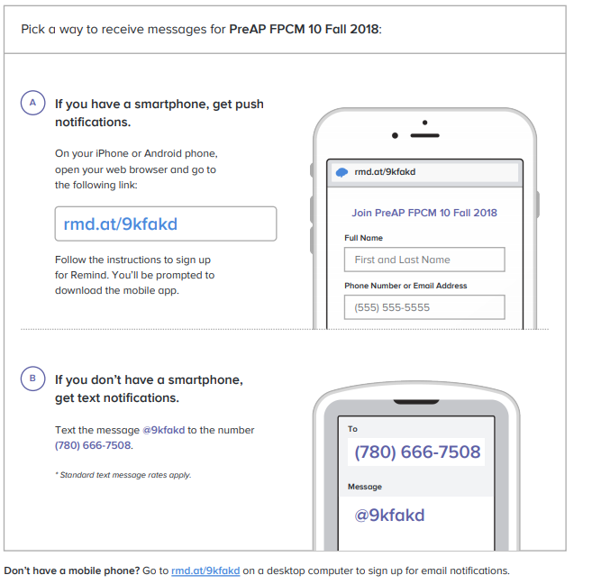
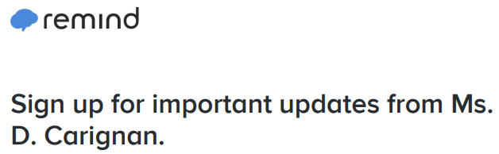

NOTE: Parents/Guardians may also choose to sign up with my remind. If you choose to sign up as a parent, please include both your name and the name of the student in your personal details. It helps me keep track of my communications

