I use the Remind APP to send out homework assignments, answer keys to assignments and reminders about upcoming Concept Checks or Comprehensive Tests. It is very important that all students sign up for REMIND. Please use the following code to sign up now (Please use your actual name to sign up for Remind so that I know who you are!)

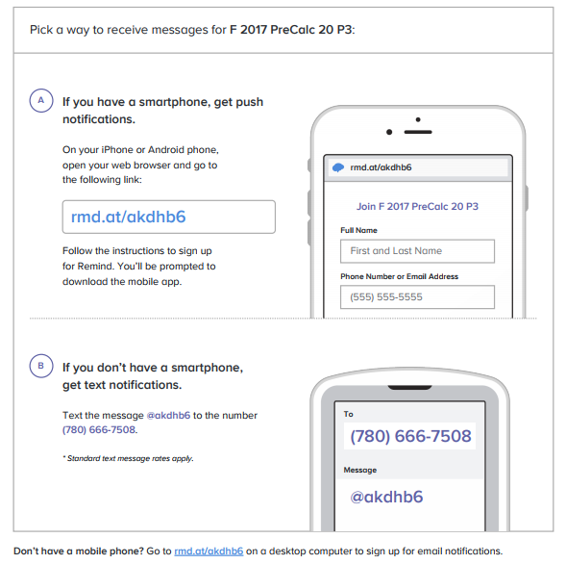

NOTE: Parents/Guardians may also choose to sign up with my remind. If you choose to sign up as a parent, please include both your name and the name of the student in your personal details. It helps me keep track of my communications!

PARENTS/GUARDIANS: Please read over the previous pages and fill in the following page. Only the following page is to be returned to me, the previous pages should be kept by the student and put in their binder.

STUDENT NAME: ________________________________________

DATE:____________________

PERIOD: 3
PreCalculus Math 20 Parent/Guardian Form 2017/2018
Please read over the course outline/syllabus that your student brought home and fill out the following information. Please have your student return this single page to Ms. Carignan.
I, ______________________________________________ (please print) (student’s parent/guardian), have read Ms. Carignan’s Pre-Calculus 20 syllabus. I understand that ______________________________________________________ (student) is responsible for adhering to the expectations and policies outlined in the course syllabus.
If I have any questions regarding the syllabus or the class, I understand that contact information has been provided above and is also available on the Campbell Collegiate website.
I understand that all attendance information, assignment information, and grades are available through the Parent and Student Portals (if you don’t have access to Parent Portal please contact the office).
If Ms. Carignan has questions about your son/daughters grades/behavior or just want to brag about their excellent work, she should contact (Please PRINT):
My contact information is:
Name(s): ________________________________ ___ __________________
Phone Number(s): __________________________ ____________________
Email Address(es): ________________________ ______________________
Thank you very much for your understanding and participation in your child’s Pre-Calculus 20 class!
This will be a successful year with your support!
Ms. Darla Carignan
Darla.carignan@rbe.sk.ca

**********PLEASE SIGN AND RETURN THE ABOVE PAGE**********
(STUDENTS KEEP THE FIRST PAGE)

