Topic 6 Extensions Project - Graphing Stories Assignment /20
Names:_______________________________________________ Period :________________
Things to include in your video and/ or presentation:
- Clearly describe what your independent and dependent variables are and their units of measurement
- A blank graph that has your axes labelled (independent and dependent variable) and a title
- A video that displays the independent vs dependent variable being compared
- An answer graph that accurately shows the independent vs dependent variable from the video
The assignment will be presented in class the week of Dec. 20-21.
 | 4 | 3 | 2 | 1
Production | The production shows evidence of appropriate editing. The story has been slowed down to accurately show graph. The graph is included in the video and the overall video flows with transitions and effects. | The production has been edited. The video is slowed down to accurately show what is happening. The graph is included and the overall production is complete. | The production has not been edited. Video is not shown more than once. The graph is not included in the video but is handed in only in hard copy. | The video has not been edited. No graph has been produced. There is simply a video showing a mathematical concept.
Graphical Representation  ( Blank graph) | The graph has been completed free of errors. Each axis is correctly labelled. Title included. The graph has been included in the video and electronic copy handed in. | The graph has been completed with 1error. Each axis is correctly labelled. The graph has been included in the video. | The graph has been completed with 2 or 3 errors. Each axis is incorrectly labelled. Title not included. | The graph has not been completed. The graph has not been included in the video or the graph contains more than 3 errors
Presentation  (Playing video) | Audience clearly knew what they were graphing (independent vs dependent variable). The video clearly matched the graph. | Audience needed to ask a question to have clear direction on what they were graphing. | Audience asked many questions on their task and /or the video did not relate to the graph. | The audience was unclear on their task and/or the video did not relate to the graph
Attractiveness/ Creativity | Makes excellent use of font, color, graphics, effects, etc. to enhance the presentation. | Makes good use of font, color, graphics, effects, etc. to enhance to presentation. | Makes very little use of font, color, graphics, effects, etc and/or occasionally these detract from the presentation content. | No use of font, color, graphics, effects etc.
Graphical Accuracy  ( Answer Graph) | The graph accurately represents the video. The graphs does not interpolate or extrapolate any information. All data is clearly labelled. | The graph accurately represents the video. The graph has a few errors, whether information is extrapolated or interpolated. | The graph is inaccurate in it's description of the video. | There is no graph.

Online FREE VIDEO EDITORS:
We video - https://www.wevideo.com/
Registration Link:
https://www.wevideo.com/invite/?code=eyJwcm9tbyI6IjJMVzlYUVlDVUI2ViIsImpvaW4iOnRydWUsInJvbGUiOjQ2NDc0MX0=
Have the students:
- Log in to google apps account
- Have them click on the link in the doc and then select either Join with a new account [if they don’t have an existing WeVideo account] or Join with an Existing Account [if they do have an existing personal WeVideo account]
  - Make sure they select the correct option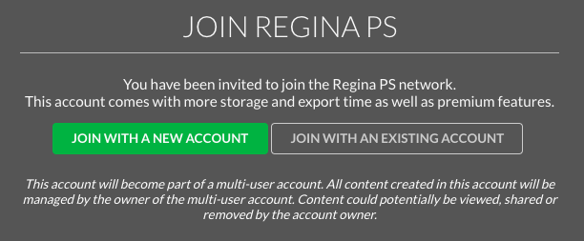
- In the next window click on the Login with Google or clicking on the G below Sign Up With: [depending on which option you chose]
- Enter your division google email address and password
- Click Log In
- Allow any access requests
- You should be in……
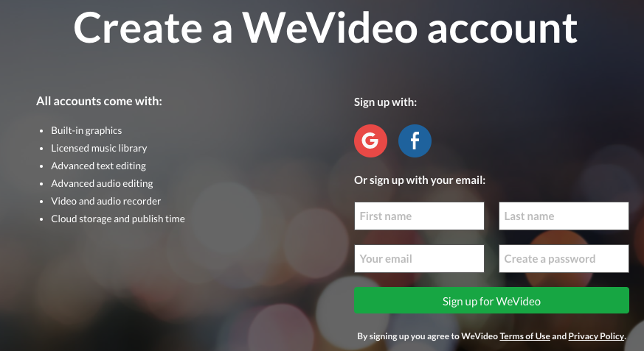

You must JOIN our classroom GROUP in WE VIDEO:
- In your bottom left hand corner of your dashboard hit the button:

2. Type in the group code:
How to Create a Video
- Be sure you are in Google Chrome
- Click on the Create new Video link
- Click on Project
- Type the Title (Include the names of the group members in your title)
- Click on Personal (just one person in your group needs to do these steps)
- Be sure your video from your phone is uploaded to your Google drive.
- Import your video by clicking on the green cloud with the arrow
How to use WE VIDEO

For tutorial Videos on how to use We video click the question mark in the top right hand corner

To find a timer, a website you can use is:
https://giphy.com/

Websites to create graphs :
Kids Zone Create a graph - https://nces.ed.gov/nceskids/graphing/classic/line.asp
Chart Go - http://www.chartgo.com/
Online chart Tool - http://www.onlinecharttool.com/

