STUDENT NAME: ________________________________________

DATE:____________________

PERIOD: 1

Math 9 Parent/Guardian Form 2016/2017

I, ______________________________________________ (please print) (student’s parent/guardian), have read Ms. Carignan’s MATH 9 syllabus. I understand that ______________________________________________________ (student) is responsible for adhering to the expectations and policies outlined in the course syllabus.
If I have any questions regarding the syllabus or the class, I understand that contact information has been provided above and is also available on the Campbell Collegiate website.
I understand that all attendance information, assignment information, and grades are available through the Parent and Student Portals.
If Ms. Carignan has questions about your son/daughters grades/behavior or just want to brag about their excellent work, she should contact (Please PRINT):
My contact information is:
Name(s): ________________________________ ___ __________________
Phone Number(s): __________________________ ____________________
Email Address(es): ________________________ ______________________
I prefer:
(daytime or evening)
(email or phone)
Thank you very much for your understanding and participation in your child’s MATH 9 class!
This will be a successful year with your support!
Ms. Carignan

**********PLEASE SIGN AND RETURN THIS PAGE**********

Teacher: Ms. Darla Carignan
Email: Darla.carignan@rbe.sk.ca

Math Help:
Students are encouraged to visit http://carignanmath.weebly.com/ for extra help. Math videos and supplementary materials will be posted.

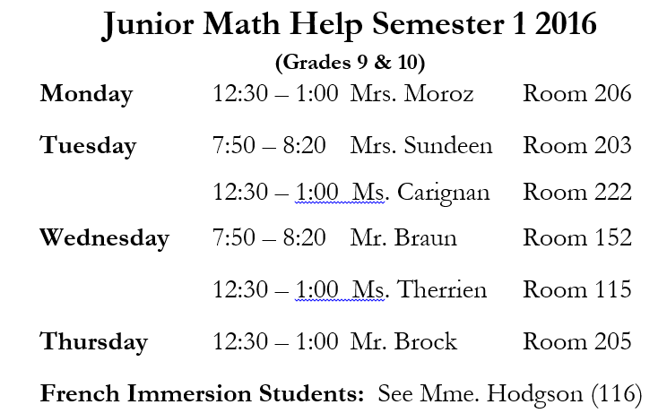
Campbell Math Teachers volunteer their time to provide a math help schedule. Following is the Junior Math help schedule (grades 9 and 10):

The following link will provide you with access to teaching videos corresponding to the Saskatchewan Math 10 curriculum. These videos can be useful for your student or for you if you wish to understand what is happening in the classroom!
Shortened Link: goo.gl/SkSuXY
Full Link (in case of problems with the shortened link): https://www.carlton.srsd119.ca/wordpress/index.php/students/departments/math/video-lessons/math-9-videos-2/

Student/Parent Communication
You, as a Regina Public Schools student, have access to your grades online, through a link on the Campbell Collegiate website. Your login information is the same as the login information you use to log onto the school computers. This access is to help you monitor your attendance as well as assignments that may be outstanding. Parent Portal is a tool that helps parents achieve the same goal. The parent login information is available in the main office. Parents can sign up for REMIND as well, to be informed of classroom activities. If you have questions or concerns please e-mail Ms. Carignan.
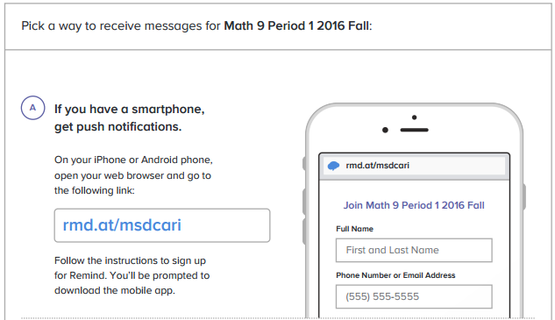
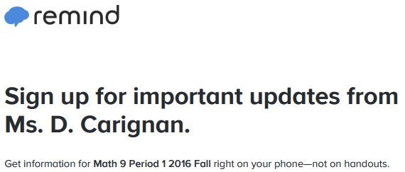

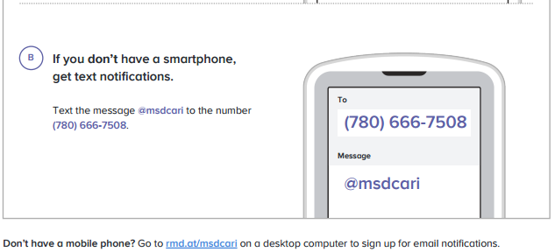

**********PLEASE KEEP THIS PAGE FOR REFERENCE**********

