Math 9 Course Outline

Teacher: Ms. Darla Carignan
Email: Darla.carignan@rbe.sk.ca

OUTCOMES COVERED OVER THE FULL YEAR COURSE
NUMERICAL OUTCOMES

Outcome: N9.1/CHAPTER 2: Demonstrate (concretely, pictorially, and symbolically) understanding of powers with integral bases (excluding base 0) and whole number exponents including:
- representing using powers
- powers with an exponent of zero
- solving situational questions.

- evaluating powers

Outcome N9.2/CHAPTER 3: Demonstrate understanding of rational numbers including:
- comparing and ordering
- relating to other types of numbers
- solving situational questions.

Outcome N9.3/CHAPTER 1: Extend understanding of square roots to include the square root of positive rational numbers.
PATTERNS & RELATIONS OUTCOMES

Outcome P9.1/CHAPTER 4: Demonstrate understanding of linear relations including:
- graphing
- interpolating and extrapolating
- solving situational questions.

- Analyzing

Outcome P9.2/CHAPTER 6: Model and solve situational questions using linear equations of the form:
- ax = b
- a(x + b) = c
- ax + b = cx + d
- a(bx + c) = d(ex + f)
- a/x = b, x ≠ 0

- x/a = b, a ≠ 0
- ax + b = c
- x/a + b = c, a ≠ 0
- ax = b + cx
Outcome P9.3/CHAPTER 6: Demonstrate understanding of single variable linear inequalities with rational coefficients including:
- comparing
- graphing.

- solving inequalities
- verifying

Outcome P9.4/CHAPTER 5: Demonstrate understanding of polynomials (limited to polynomials of degree less than or equal to 2) including:
- modeling
- generalizing strategies for addition, subtraction, multiplication, and division
- analyzing
- relating to context
- comparing for equivalency.

SHAPE & SPACE OUTCOMES

Outcome: SS9.1/CHAPTER 8: Demonstrate understanding of circle properties including:
- perpendicular line segments from the centre of a circle to a chord bisect the chord
- inscribed angles subtended by the same arc have the same measure
- the measure of a central angle is twice the measure of an inscribed angle subtending the same arc
- tangents to a circle are perpendicular to the radius ending at the point of tangency.
Outcome SS9.2/CHAPTER 1.3: Extend understanding of area to surface area of right rectangular prisms, right cylinders, right triangular prisms, to composite 3-D objects.

Outcome SS9.3/CHAPTER 7: Demonstrate understanding of similarity of 2-D shapes.

Outcome SS9.4/CHAPTER 7: Demonstrate understanding of line and rotation symmetry.

STATISTICS & PROBABILITY OUTCOMES

Outcome SP9.1/CHAPTER 9: Demonstrate understanding of the effect of:
- bias
- time and timing
- privacy
- cultural sensitivity and
- population or sample

- use of language
- ethics
- cost

Outcome SP9.2/CHAPTER 9: Demonstrate an understanding of the collection, display, and analysis of data through a project

Outcome: SP9.3/CHAPTER 9: Demonstrate an understanding of the role of probability in society.

Outcome SP9.4 Research and present how First Nations and Métis peoples, past and present, envision, represent, and make use of probability and statistics.

Organization: The more organized you are the better you will do in this class!

- Many of my notes will be in “handout” form. You need to keep all notes and assignments together and in the correct order. You need to have a SEPARATE section that contains looseleaf for assignments.
- You need to keep all of your notes until the end of the year. If you wish to only bring your current chapter to class that is fine. If you wish to keep remaining chapters in a folder in my room I can arrange for that! I will work with you to help you be more organized if that has been your past weakness!
- Please bring pencil, eraser, calculator, paper, binder and textbook to class each day. You need to have a Scientific Calculator(As you can not use phones as calculators on tests, you must learn to properly use your specific calculator as we practice throughout the chapter – that means no phones as calculators) NOTE AS WELL:

* Students may NOT use calculators that have “MathPrint” , “MultiView”, “WriteView”, “Textbook Display” or “Natural Display/expression” for assessments. Graphing calculators may not be used for assessments dealing with the graphs of functions and relations.
The following calculators will meet the needs for high school students.
    - Sharp – EL-510, 520 or 531
    - Texas Instrument – TI 30X
    - Casio – fx260

Classroom Expectations:

- If you have found math difficult in the past, please consider this an opportunity to have a “fresh start”. If you don’t understand the way something has been taught I can usually teach it in a couple several different ways – just ask!
- My classroom is a place where people feel comfortable and accepted. Please behave in ways that help make that true.
- No phones allowed for texting, phoning, facebooking or games. There will be times when phones will be allowed during class with permission. Phones will NEVER be allowed during tests so be sure to always have a standalone calculator with you!
- IPODS without internet capabilities may be used with permission while working on individual assignments. If problems arise, this privilege will be taken away.
- Extra help: Please always ask if you have any questions. My extra help hours will be posted on the calendar outside my room. Most weeks I will be available for at least three extra help sessions either after school or at noon. Campbell Collegiate Math Teachers also provide a scheduled math help session every day – please check the posted signs for times, locations and teachers’. Math help is offered every lunch from 12:40-1:10 and Tuesday after school from 3:30-4:00. There will be an assigned teacher to assist you with your Math needs, check for the list posted in every Math room.
- There is no such thing as a stupid question! Ask if you don’t understand!!!!!!!

THINGS I WILL BE STRICT ABOUT:
- You MUST have a scientific Calculator for this class. You can purchase an inexpensive one at the dollar store or a more expensive one. You will not be allowed to use your phone as a calculator. The reason for this is is that we will be doing some complicated calculations and I need you to know how to do those calculations on the same calculator every day (and since you absolutely can not use your phone during tests you need to know how to completely and properly use the calculator you have chosen to purchase)
- Bringing a pencil, eraser and straight edge to class
- As this classroom has rug on the floor, I will be limiting the amount of food and drink brought into the class except on special days. Please feel free to bring water into the class at any time however!

TEXTBOOK:
You will be issued a textbook to USE for the year. You do not own this book. It needs to come back at the end of the semester looking like it did at the beginning.
Math Makes Sense 9 - Pearson (Replacement Cost $110)
-
Evaluation:

- Evaluation will be cumulative and continuous.

Your mark will be broken down as follows:

1. Semester Work:
Formative Assessments (Tests) → 50%
Assignments, Concept Checks Quizzes → 30%
Semester I & II Midterms → 10%

2. Semester I & II Final Exams → 10%

Math Help:
Students are encouraged to visit http://carignanmath.weebly.com/ for extra help. Math videos and supplementary materials will be posted.

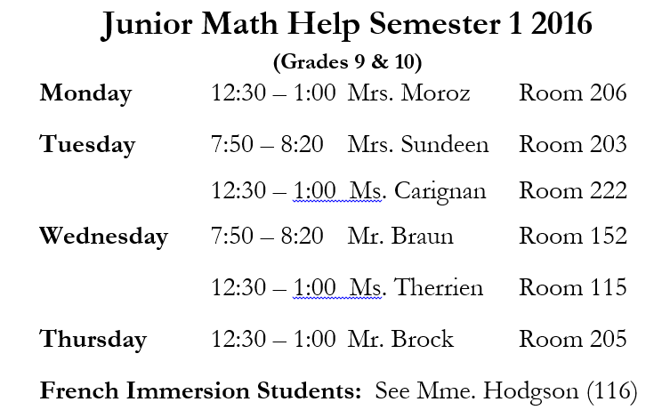
Campbell Math Teachers volunteer their time to provide a math help schedule. Following is the Junior Math help schedule (grades 9 and 10):

The following link will provide you with access to teaching videos corresponding to the Saskatchewan Math 10 curriculum. These videos can be useful for your student or for you if you wish to understand what is happening in the classroom!
Shortened Link: goo.gl/SkSuXY
Full Link (in case of problems with the shortened link): https://www.carlton.srsd119.ca/wordpress/index.php/students/departments/math/video-lessons/math-9-videos-2/

