Course Outline: Pre-AP PreCalculus 20 Period 3
Fall 2017 Semester

Teacher: Ms. Darla Carignan
Email: Darla.carignan@rbe.sk.ca

Students are encouraged to visit one of the following two websites for class information, extra help, math videos & supplementary materials:

http://carignanmath.weebly.com or http://sundeenfprecalc20.weebly.com/

Course Content and Outcomes:
Outcome for Ch. 3 and 4.2
- P20.7 Demonstrate understanding of quadratic functions of the form y=ax²+bx+c and of their graphs.
- P20.6 Expand and demonstrate understanding of factoring polynomial expressions.
Outcomes for Ch. 4.1,3,4 and 8
- P20.8 Demonstrate understanding systems of quadratic equations including the solution of: single variable equations, systems of linear-quadratic and quadratic-quadratic equations in two variables.
Outcome for Ch. 9
  - P20.9 Expand and demonstrate understanding of inequalities including: one-variable quadratic inequalities and two-variable linear and quadratic inequalities.
Outcome Ch.5
- P20.2 Expand and demonstrate understanding of radicals with numerical and variable radicands including: computations and solving equations (limited to square roots and one or two radicals).
Outcome Ch.6
- P20.3 Expand and demonstrate understanding of rational expressions and equations (up to and including degree 2 numerators and denominators) including: equivalent forms of expressions, operations on expressions and solving equations that can be simplified to linear or quadratic equations.
Outcome Ch. 7.4
- P20.11 Demonstrate understanding of reciprocal functions of: linear functions and quadratic functions.
Outcome Ch.7
- P20.1 Demonstrate understanding of the absolute value of real numbers and equations and functions involving the absolute value of linear and quadratic functions.
Outcome Ch. 1
- P20.10 Demonstrate understanding of arithmetic and geometric (finite and infinite) sequences and series.
Outcome Ch. 2
- P20.4 Expand and demonstrate understanding of the primary trigonometric ratios including the use of reference angles (0° ≤ θ ≤ 360°) and the determination of exact values for trigonometric ratios.
- P20.5 Demonstrate understanding of the cosine law and sine law, including the ambiguous case.

Evaluation:

Quizzes, Assignments & Projects 40%
Comprehensive Tests (Three Tests worth 15% each) 45%
Final Exam 15%
TOTAL 100%

DAILY WORK: FOUNDATIONAL ASSIGNMENTS & UPPER LEVEL ASSIGNMENTS
One of the most important things you can do to be successful in this class is to do your daily work. Most days I will give you and assignment that is broken into two parts:
- The first part of each daily assignment is the Foundational Assignment (FA). This assignment contains the fundamental questions that cover the basic foundation of the concept, and will cover the minimum of skills needed to pass the class. This assignment counts for formative marks on a daily basis and counts towards the incentive. Completing this assignment will help you to earn up to a 60% average in this class. These assignments will be due to be handed in for formative evaluation. These assignments must be labelled properly, be neatly completed and show all appropriate work in order to receive credit.
- The second part of the assignment is called the Upper Level Assignments (ULA). This assignment contains questions which will provide you with practice questions that are necessary to understand if you wish to get a mark above a minimum of 60%. Homework checks on this homework will be conducted and recorded on a regular basis but will not be counted towards the incentive.

CLASSROOM EXPECTATIONS:
- If you don’t understand the way something has been taught I can usually teach it in a couple several different ways – just ask!
- My classroom is a place where people feel comfortable and accepted. Please behave in ways that help make that true.
- Phone use: During teaching time, phones must either be left in your locker or placed in your slot in the phone holder at the front of the classroom. On most days you will be allowed to retrieve your phone after I am done teaching. This privilege will be removed if you choose to use your phone inappropriately in class.
  - Phones will NEVER be allowed during tests so be sure to always have your graphing calculator with you! I do not usually have extra calculators so you must come prepared.
- Extra help: Please always ask if you have any questions. Campbell Collegiate Math Teachers also provide a scheduled math help session every day – please check the posted sign in my classroom for times and locations
- There is no such thing as a stupid question! Ask if you don’t understand!!!!!!!
- You must come prepared for class – bring all supplies and your textbook every day.

SUPPLIES:
Organization: The more organized you are the better you will do in this class!
- Loose Leaf
- Graph Paper
- Binder
- Highlighters

- Coloured Pens
- Ruler
- Pencils
- Sticky Notes

- Eraser
- Scientific Calculator
- Graphing Calculator (See below)

- Many of my notes will be in “handout” form. You need to keep all notes and assignments together and in the correct order. You need to have a SEPARATE section that contains loose leaf and Graph Paper for assignments.
- You need to have a Texas Instrument Graphing Calculator in order to complete various Pre-AP portions of this course (and for each subsequent Pre-AP and AP Math course). The AP final exam in grade 12 is written using the graphing calculator for half the test and no access to any calculator for the other half. Below are photos of some of the types and varieties that will meet the needs of the students.
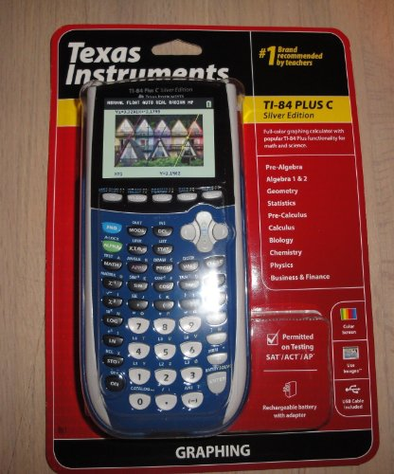
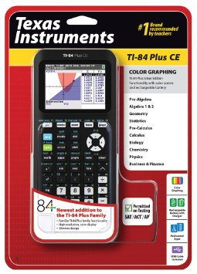
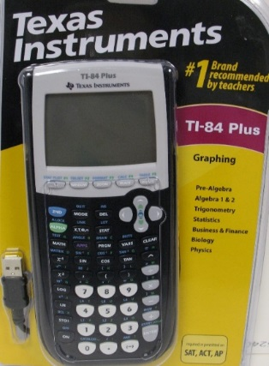

TI-84 Plus
- Regular black or Silver Case
- This calculator has a black and white screen and uses replaceable batteries
TI-84 Plus CE
- The case comes in various colours
- This Calculator has a coloured screen and a rechargeable battery
- It is thinner and lighter than the previous two models
TI-84 Plus C
- The case comes in various colours
- This Calculator has a coloured screen and a rechargeable battery
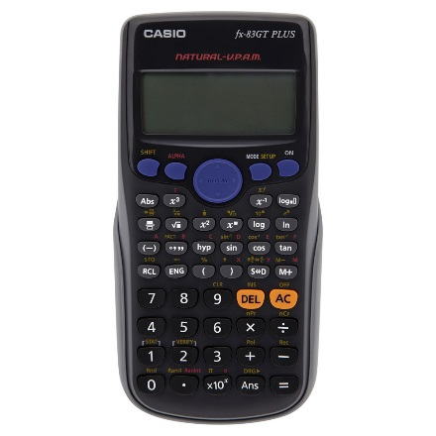
- You will also need a scientific calculator as many assessments will allow a calculator but not a graphing calculator. You will NOT be allowed to use any calculators that say WriteView, Multi-View, Textbook Display or Natural Display/Expression.
- To test to see if your calculator is approved or not, use your calculator to find . If the calculator is capable of giving you an answer of it is NOT AN APPROVED CALCULATOR. One of the most common non approved calculators is the one currently found at Costco (with an orange AC key )and looks like

