Calculus 30: Outcome 5 Day 1 – Relative & Absolute Extrema (tEXTBOOK: 4.2)

To learn to use the first derivative to find maximum and minimum values of a function and to use the First Derivative Test to find increasing and decreasing intervals of a function.

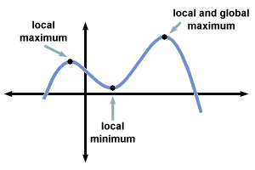A graph of a function may have a series of highs and lows.

* The highest point is called the **Global or Absolute Maximum**
* The lowest point is called the **Global or Absolute Minimum**
* Together, the lowest and highest points are called the **Global or Absolute EXTREMA.**
* In general, every high point is called a **Local or Relative Maximum**
* In general, every low point is called a **Local or relative Minimum**
* Together, all high and low points are called **Local or Relative Extrema**
* 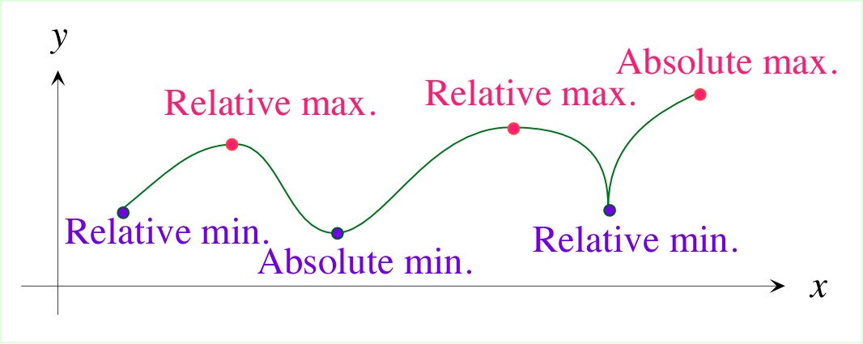All maximum and minimum points occur at places where either the tangent line to the graph has a slope of zero, or where the tangent line does not exist.
  + **CRITICAL POINTS** on the graph are places where local extrema exist on the graph of the function. These points, c, exist where either f’(c) = 0 or f’(c) does not exist (being undefined or undifferentiable).
  + **Note:** Not all places on the graph where f’(c) = 0 or f’(c) does not exist are critical points. For example

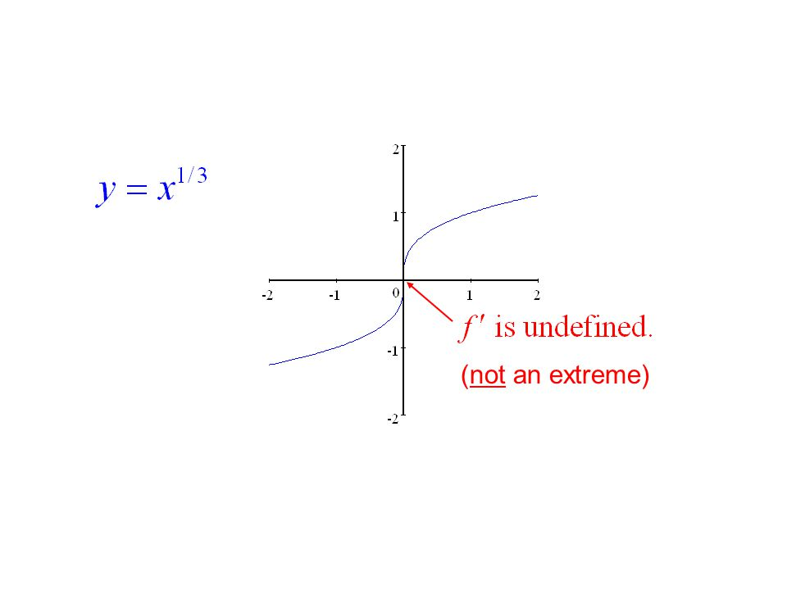

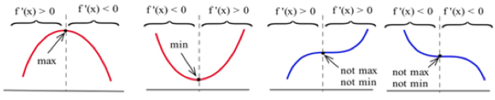

Ex #1:

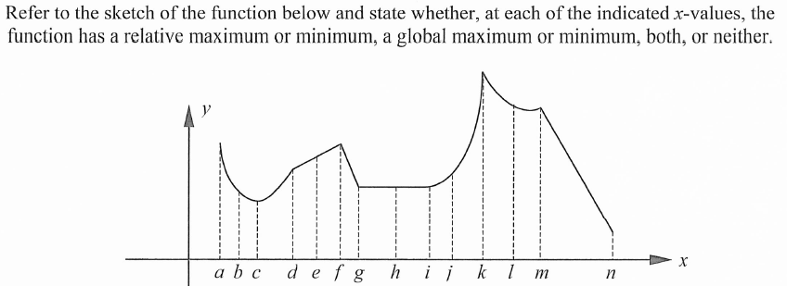

* Does the above graph show a closed interval, an open interval or an infinite interval?
* Write the interval using interval notation

Ex #2: Find the coordinates of any maximum or minimum values for the function y = 2x3 -24x + 21.

* Can you tell if they are maximum values or minimum values from your answer? Can you tell if they are local or absolute extreme values from your answer?

Ex #3: Find the critical numbers of the function 

Ex #4: Find the critical numbers for 

THE EXTREME VALUE THEOREM:

If f(x) is continuous on a **closed interval** [a, b], then f(x) has both a global maximum and a global minimum on this interval.

Ex #5: Without drawing a graph, find the absolute extrema of the function f(x)=x3 – 12x on the interval [-5, 3].

STEPS:

1. Find all critical numbers of f(x) on the given closed interval
2. Find the coordinates of the critical numbers
3. Evaluate the function at the endpoint of the interval to find the endpoint coordinates
4. The coordinate with the largest “y” value in the above steps is the absolute maximum. The coordinate with the lowest y value is the global minimum.

**OUTCOME 5 DAY 1 ASSIGNMENT (Section 4.2 in Text)**

The following questions:

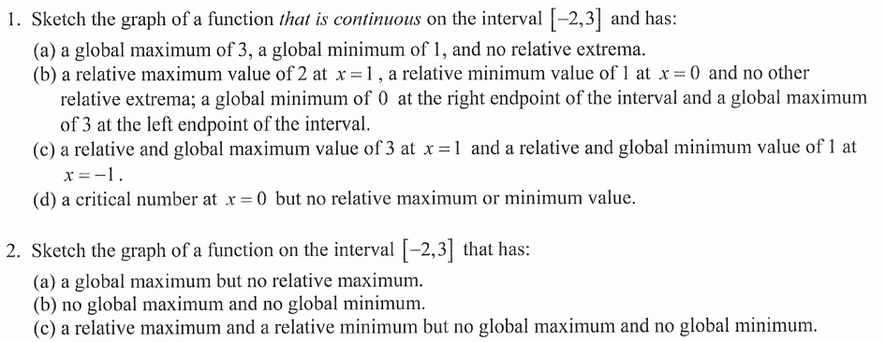

FA The Above Questions Plus: TEXTBOOK P176 #1ii, 2 aefh, 3a-e, 4(without graphing)a-e, g

MLA TEXTBOOK P176 #3g-l, 4hi, 6, 7

Calculus 30: Outcome 5 Day 2 – The First Derivative test: increasing and decreasing intervals) (tEXTBOOK: 4.1 & 4.3)

To determine intervals in which a graph is increasing and decreasing, and to use the First Derivative Test to find these intervals.

* An intuitive explanation of increasing vs decreasing functions can be found in the images below:

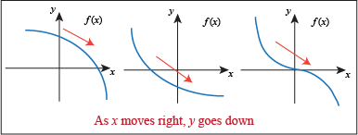 INCREASING FUNCTIONS DECREASING FUNCTIONS

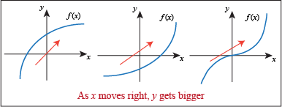

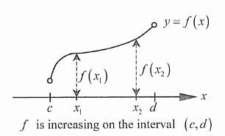

* We specifically will talking about INTERVALS where functions increase or decrease.
  + A function, f(x), is said to be increasing on the open interval (c, d) if all f(x1) < f(x2) when the order of our x terms satisfies c < x1 < x2 < d

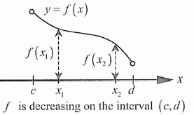

* + A function, f(x), is said to be decreasing on the open interval (c, d) if all f(x1) > f(x2) when the order of our x terms satisfies c < x1 < x2 < d
* 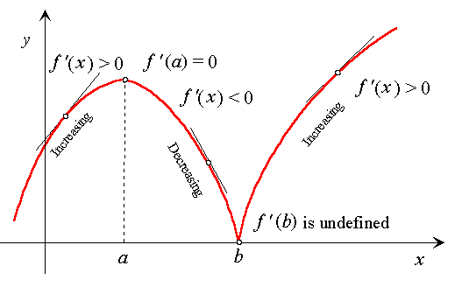 In general, we say that the derivative of a function will be positive for all values of x in intervals where the graph is increasing and the derivative of a function will be negative for all values of x in intervals where the graph is decreasing.

INCREASING/DECREASING INTERVAL TEST

Suppose f(x) is a function that is continuous on the open interval (c, d)

* If f’(x) > 0 for all , with the exception on a finite number of points at which f’(x) = 0 or f’(x) DNA, then f(x) is INCREASING on (c, d)
* If f’(x) < 0 for all , with the exception on a finite number of points at which f’(x) = 0 or f’(x) DNA, then f(x) is DECREASING on (c, d)

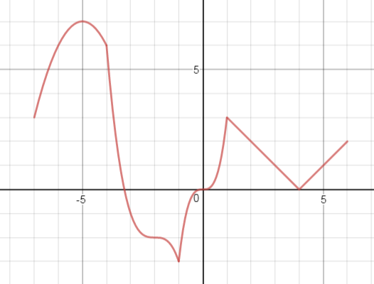Ex #1: State intervals of increase and intervals of decrease for the following graph.

* In the last section we learned to use the first derivative to determine locations of local extrema, but we weren’t able to determine if those extrema were maximums or minimums. Today we will learn how to distinguish between maximum and minimum extrema.

THE FIRST DERIVATIVE TEST:

If *c* is a critical number of a continuous function f(x), then:

* f(x) has a **Relative Minimum** at the value *x = c* if the value of f’(x) switches signs from negative to positive at *c*
* f(x) has a **Relative Maximum** at the value *x = c* if the value of f’(x) switches signs from positive to negative at *c*

Ex #2 : Use sign analysis to find the open intervals in which the function  is increasing and decreasing. Find the coordinates of any relative extrema and state if they are a maximum or a minimum.

Ex #3 : Use sign analysis to find the open intervals in which the function  is increasing and decreasing. Find the coordinates of any relative extrema and state if they are a maximum or a minimum.

Ex #4 : Use sign analysis to find the open intervals in which the function  is increasing and decreasing. Find the coordinates of any relative extrema and state if they are a maximum or a minimum.

Ex #5 : Shown below are the graphs of f(x0, f’(x) and another function g(x). Which is which?

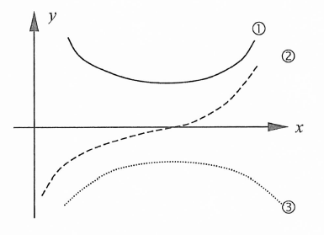

**OUTCOME 5 DAY 2 ASSIGNMENT (Section 4.1 & 4.3 in Text)**

FA P 170 #1 and the following:

Use sign analysis to find the open intervals in which the following functions are increasing and decreasing. Find the coordinates of any relative extrema and state if they are a maximum or a minimum.

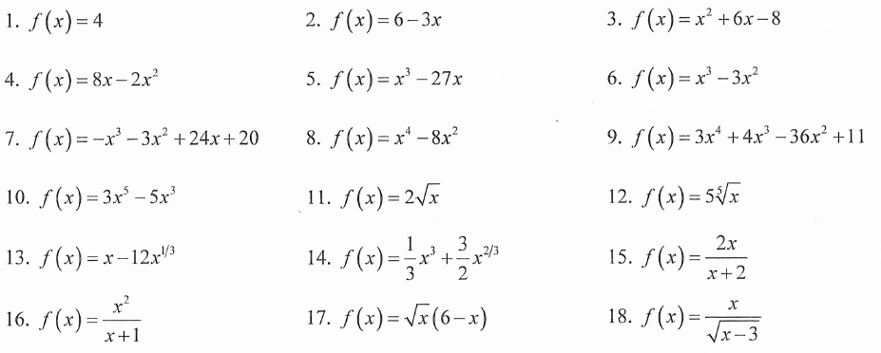



20. Match each function with the graph of its derivative. The scales are not necessarily the same from one graph to the next.

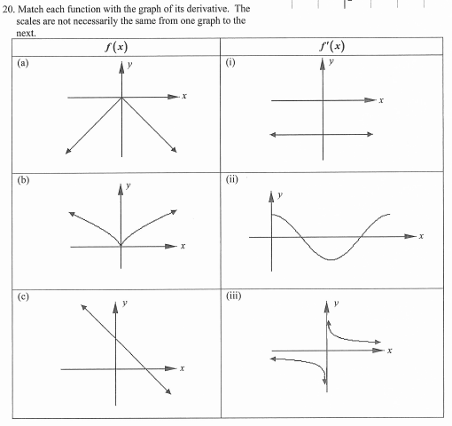

THIS QUESTION IS CONTINUED ON THE NEXT PAGE….. ☺

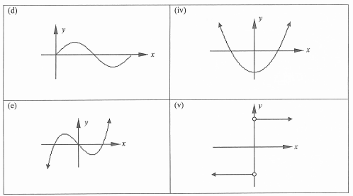

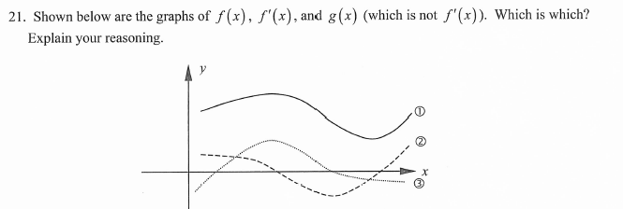

MLA: P 182 #4, 5, 6 & the following

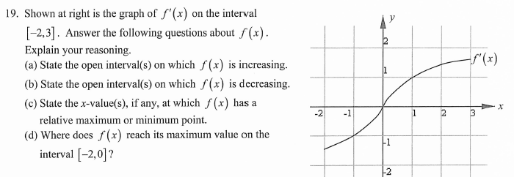

Calculus 30: SOLUTIONS TO WORKBOOK ASSIGNMENTS

**SOLUTIONS TO: OUTCOME 5 DAY 1 ASSIGNMENT**

EXTRA QUESTIONS:

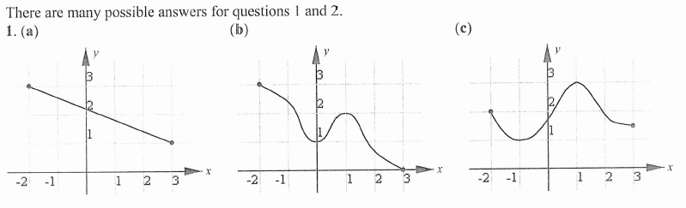

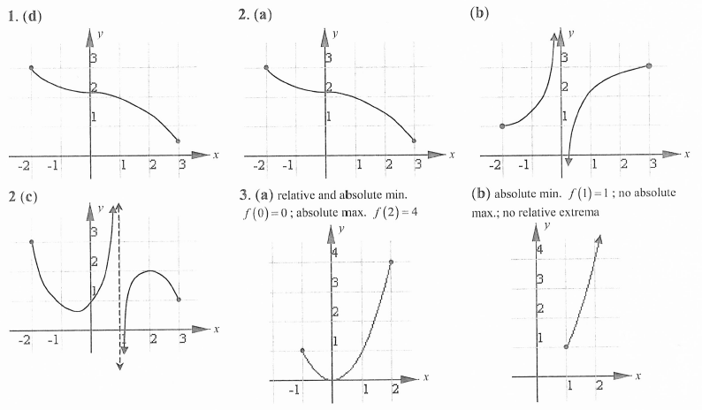

**SOLUTIONS TO: OUTCOME 5 DAY 2 ASSIGNMENT**

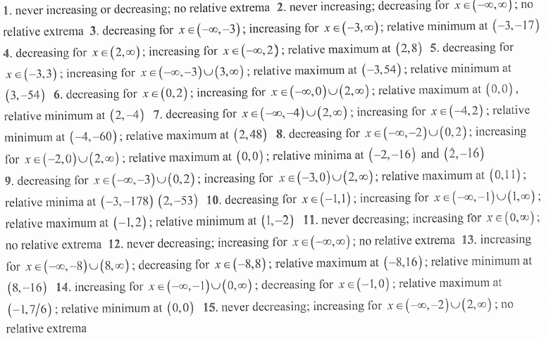

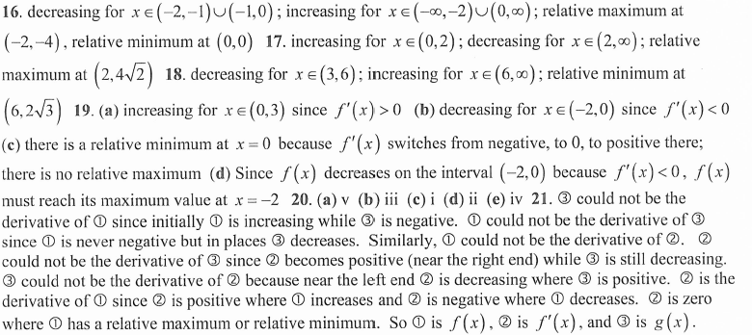

**VIDEO LINKS:**

OUTCOME 5: DAY 1

Mr. C (Day 1 & 2)<https://www.youtube.com/watch?v=c8l78QZQLvs>

Mr. S <https://www.youtube.com/watch?v=b8nr3fzXHGc&list=PLXAK0v3528m3opNuT8qDcea1Lmjj_KidD&index=27>

CC <https://www.youtube.com/watch?v=BWba185jOEo&feature=youtu.be>

OUTCOME 5: DAY 2

Mr. S <https://www.youtube.com/watch?v=RC7VV2Y0ncE&list=PLXAK0v3528m3opNuT8qDcea1Lmjj_KidD&index=28>

CC <https://www.youtube.com/watch?v=dgCwSw0vt0s&feature=youtu.be>

OUTCOME 5: DAY 3

Mr. C <https://www.youtube.com/watch?v=la80ax2mwcg>

Mr. S <https://www.youtube.com/watch?v=gGYbiIkfmus&list=PLXAK0v3528m3opNuT8qDcea1Lmjj_KidD&index=29>

CC <https://www.youtube.com/watch?v=8R0mncfSaMQ&feature=youtu.be>

OUTCOME 5: DAY 4

Mr. C <https://www.youtube.com/watch?v=J4e5gKCuJZw>

Mr. S <https://www.youtube.com/watch?v=opHLhD0Bm6w&index=30&list=PLXAK0v3528m3opNuT8qDcea1Lmjj_KidD>

CC <https://www.youtube.com/watch?v=A75WKEgn-t0&feature=youtu.be>

OUTCOME 5: DAY 5

Mr. S

#1: <https://www.youtube.com/watch?v=nyTvywYx_18&index=31&list=PLXAK0v3528m3opNuT8qDcea1Lmjj_KidD>

#2: <https://www.youtube.com/watch?v=dzlrdcpgCQg&index=32&list=PLXAK0v3528m3opNuT8qDcea1Lmjj_KidD>

CC <https://www.youtube.com/watch?v=oQ6JjCar6oI&feature=youtu.be>

OUTCOME Summary (We did f”(x) in the last outcome): <https://www.youtube.com/watch?v=k0bnC-HkRvc&feature=youtu.be>